**3.1 Implementing a Simple Firewall**

**Task 1.A**

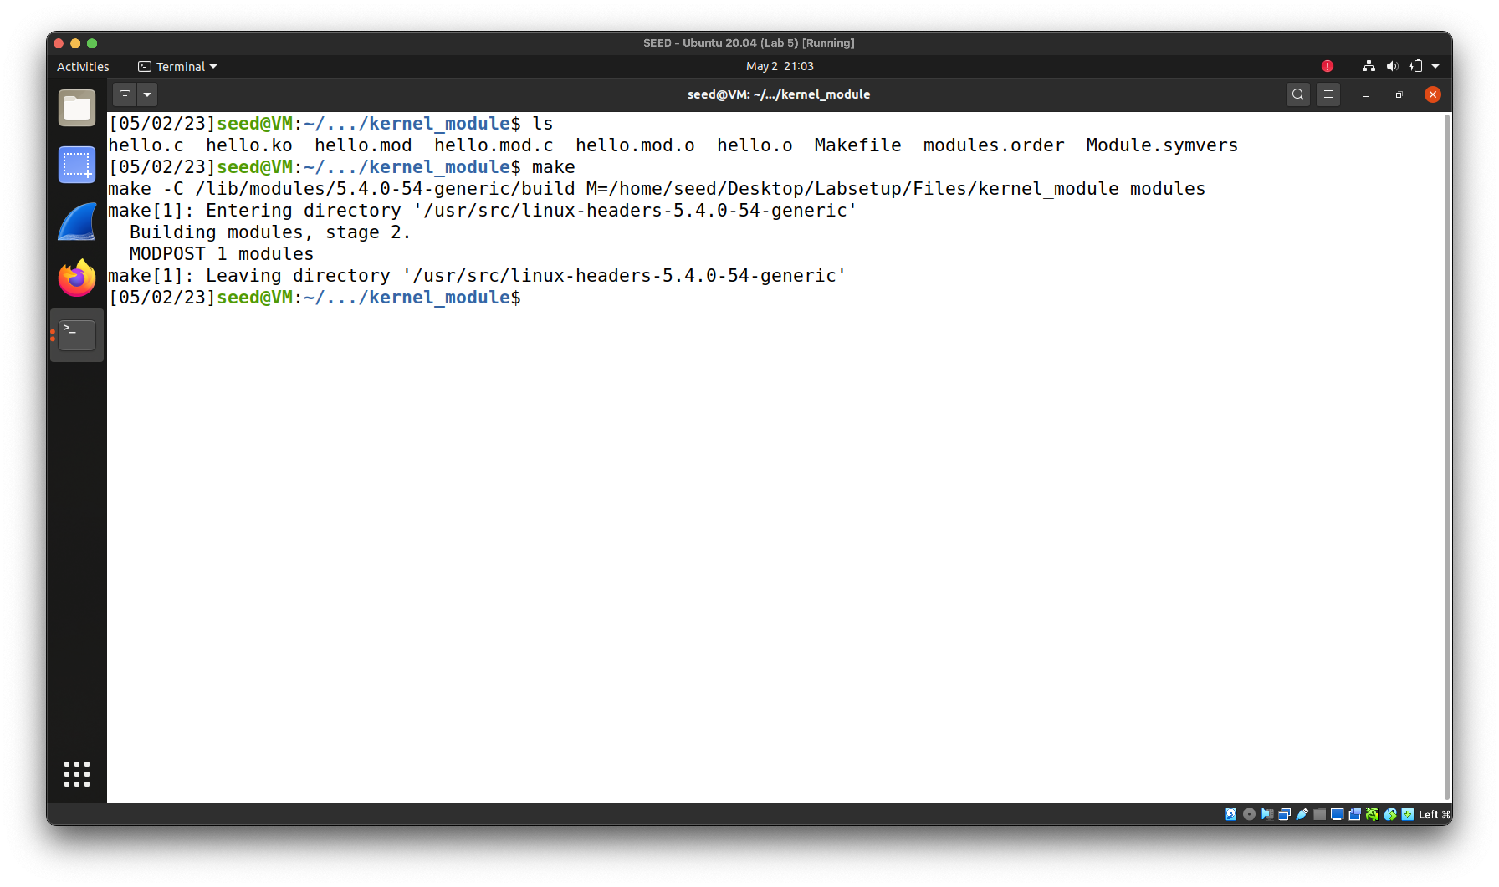

Compile.

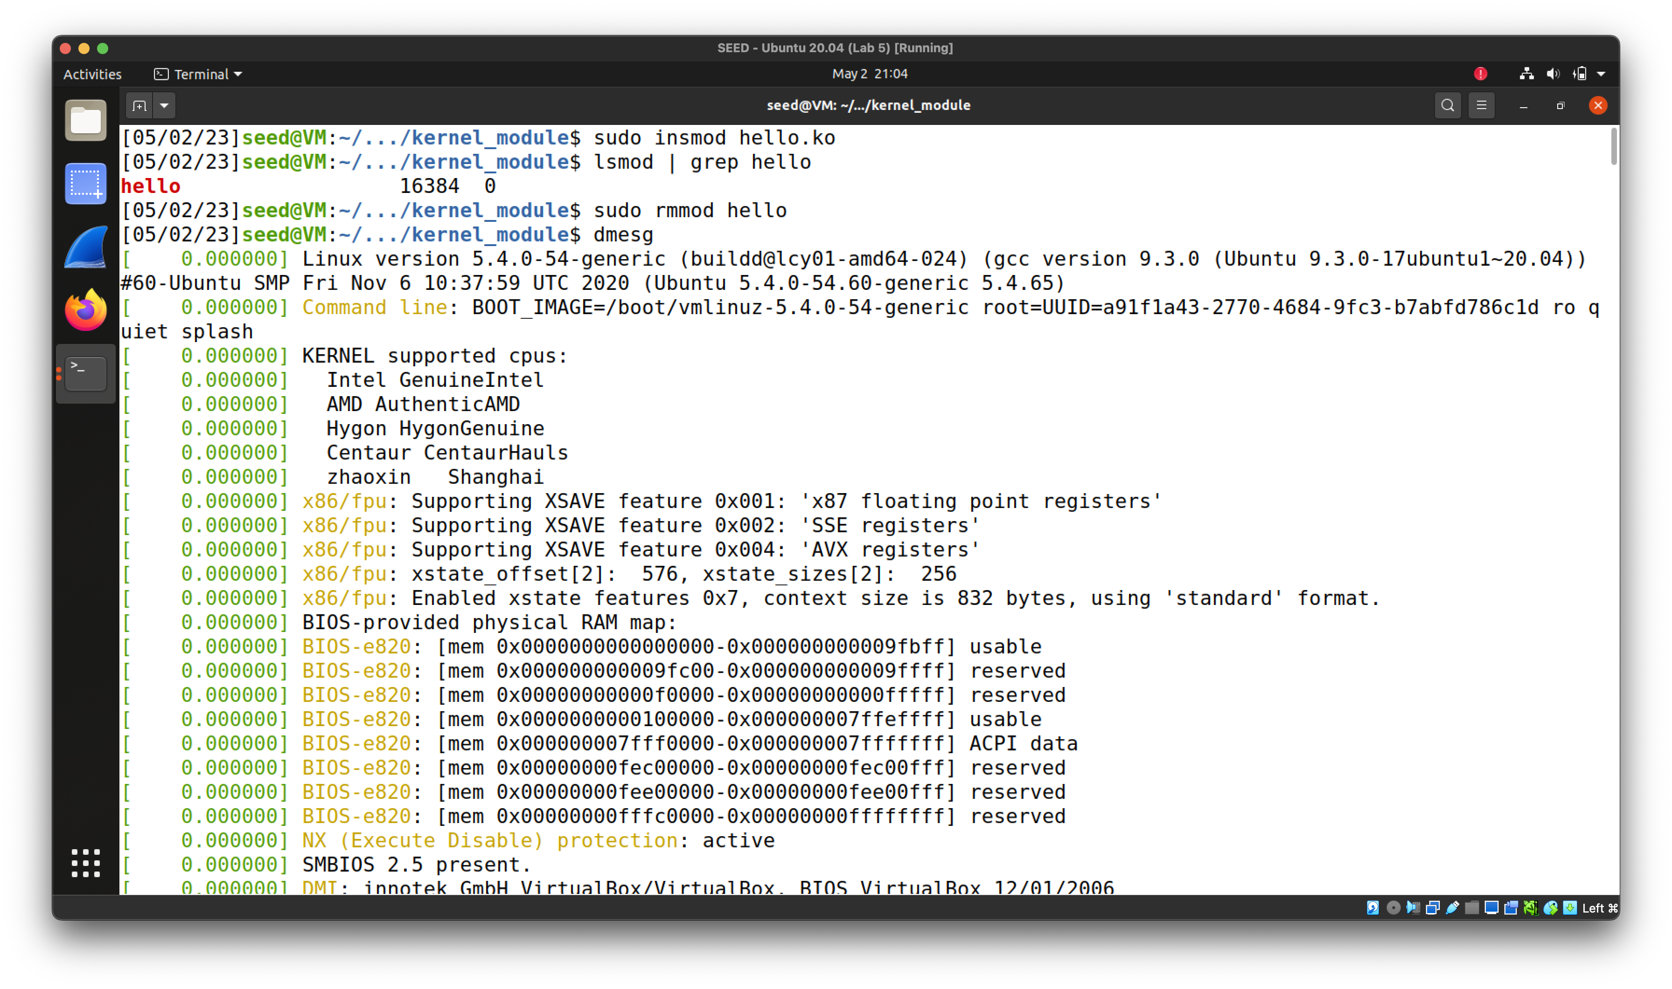

Load module.

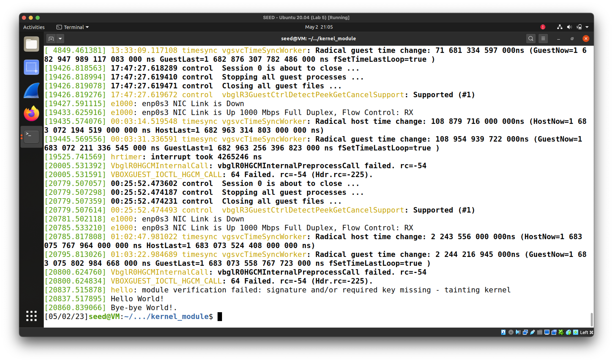

Print the system log.

**3.2 Implement a Simple Firewall Using Netfilter**

**Task 1.B**

**1.**

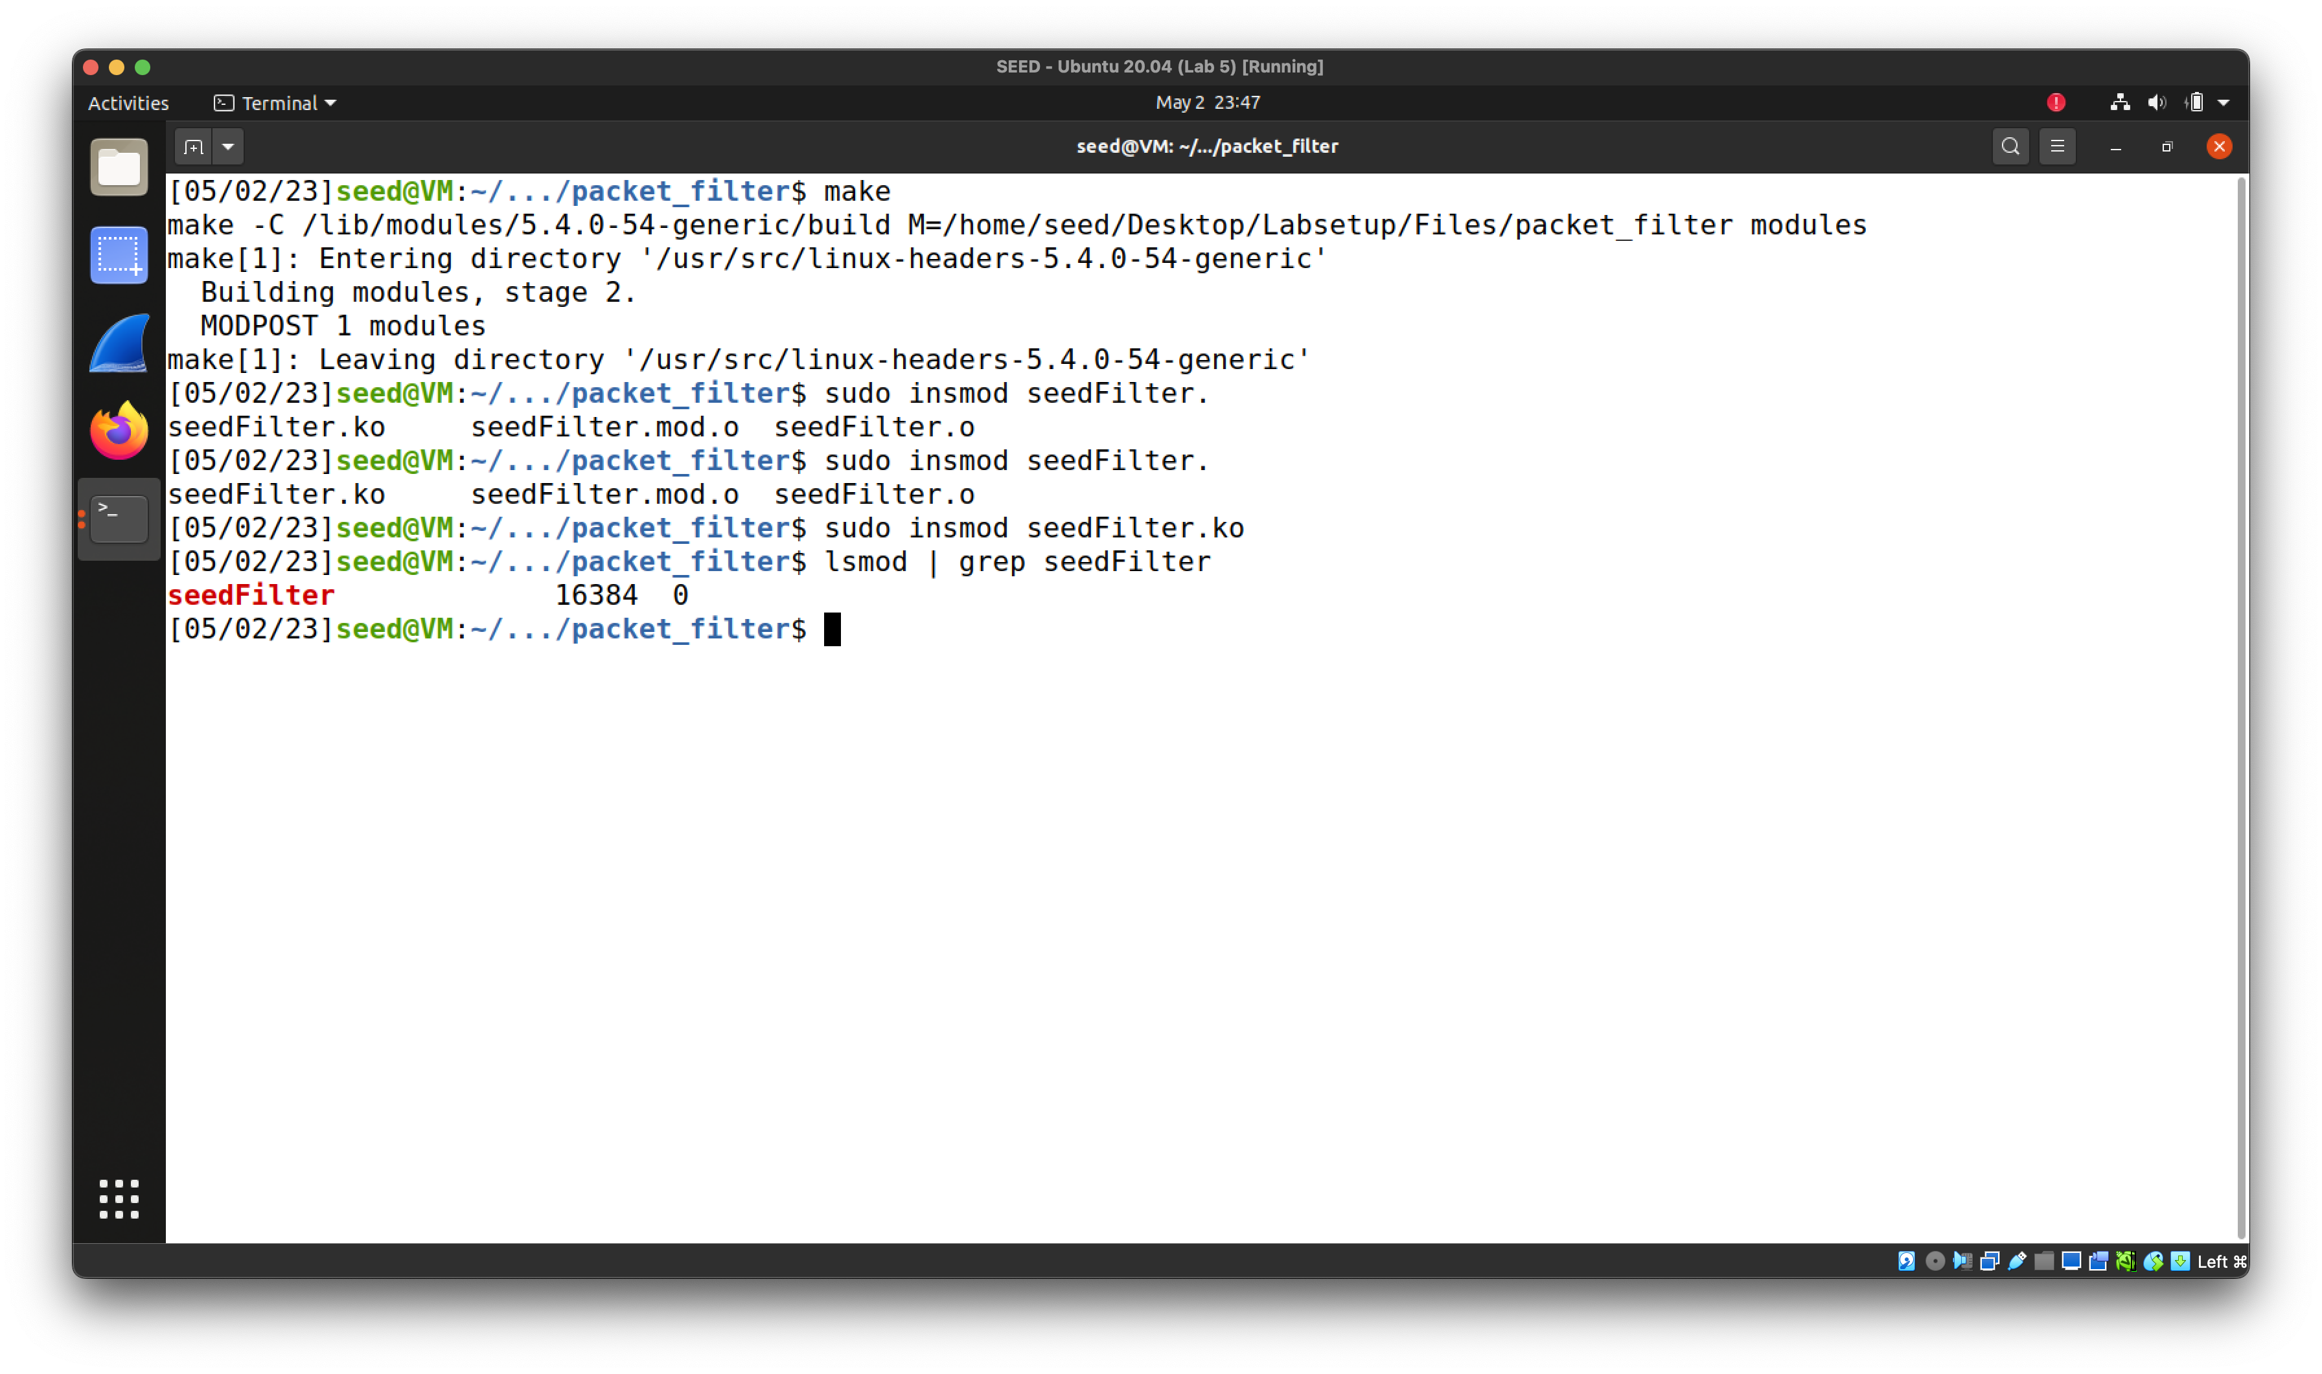

Compile and load seedFilter.

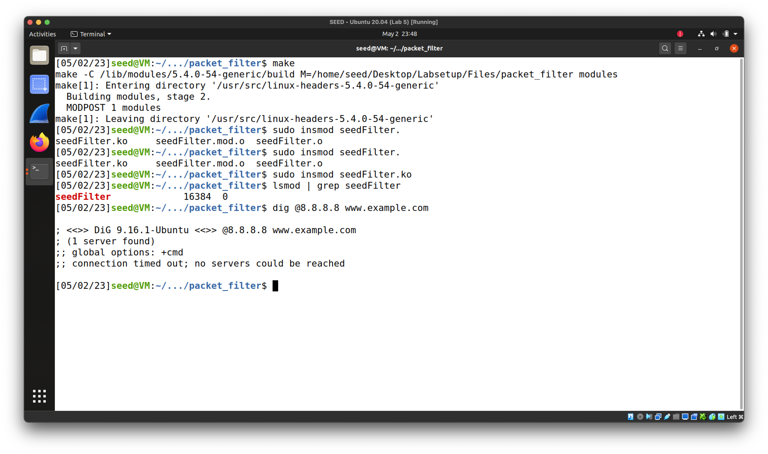

Connection timed out – firewall is working.

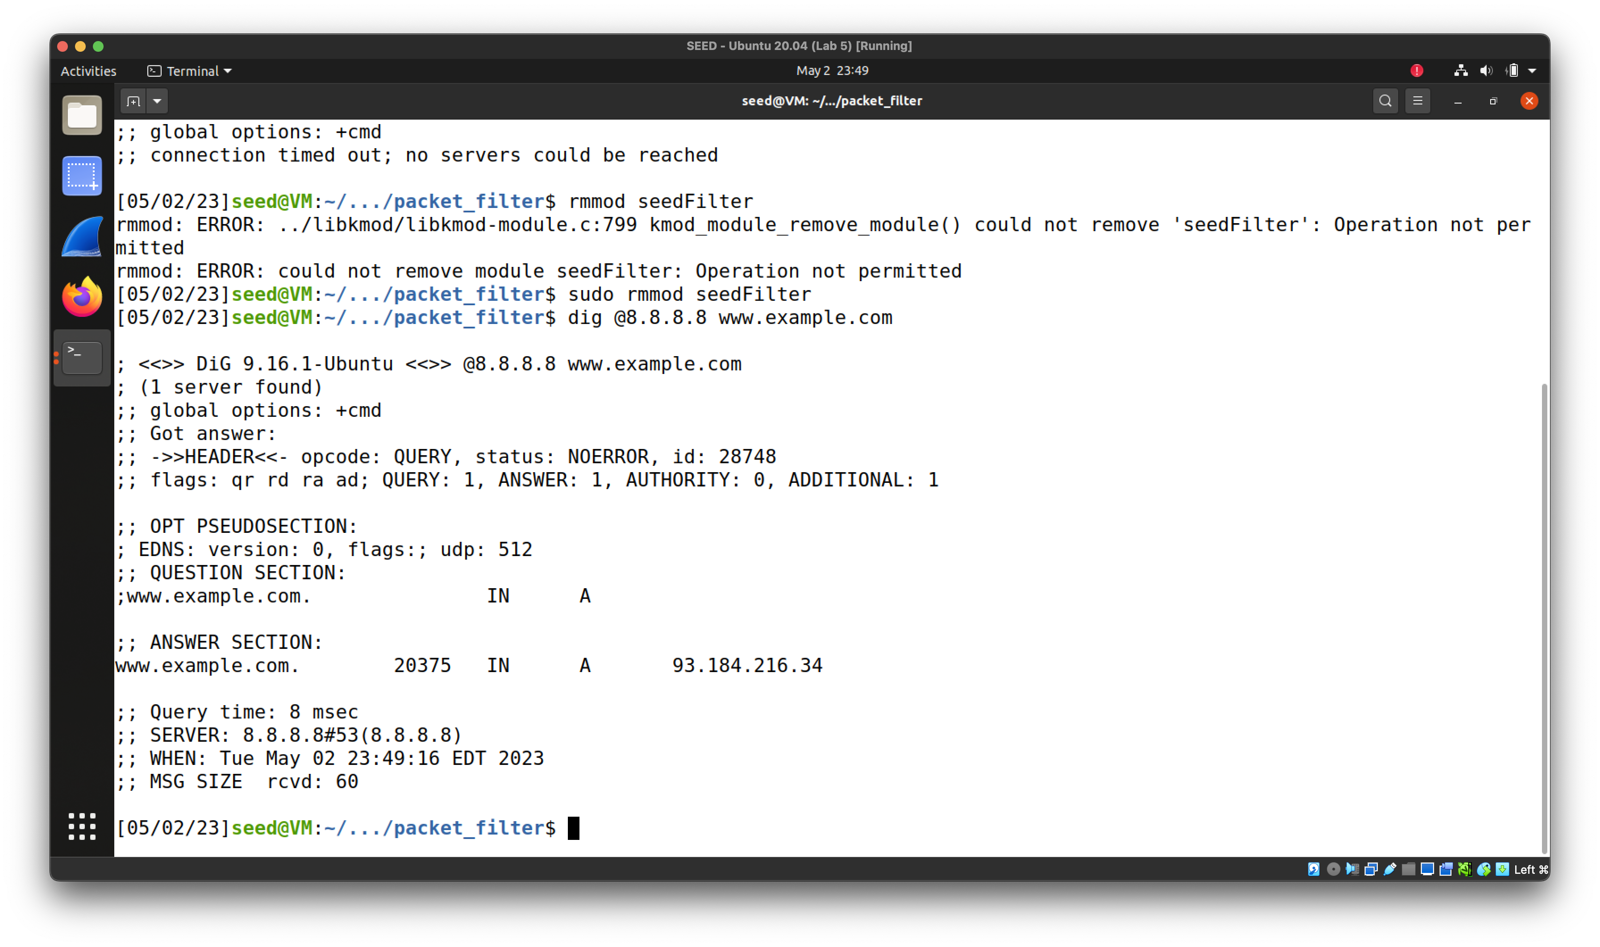

Unload seedFilter - able to get a response from 8.8.8.8 now.

**2.**

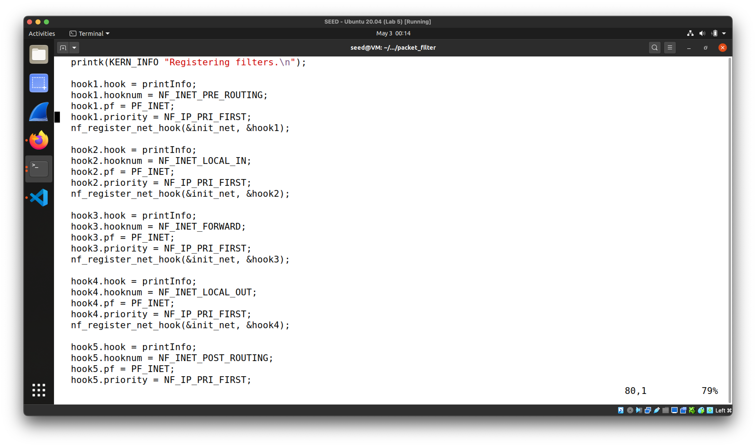

Code snippet of `printInfo` function linked to all 5 hooks.

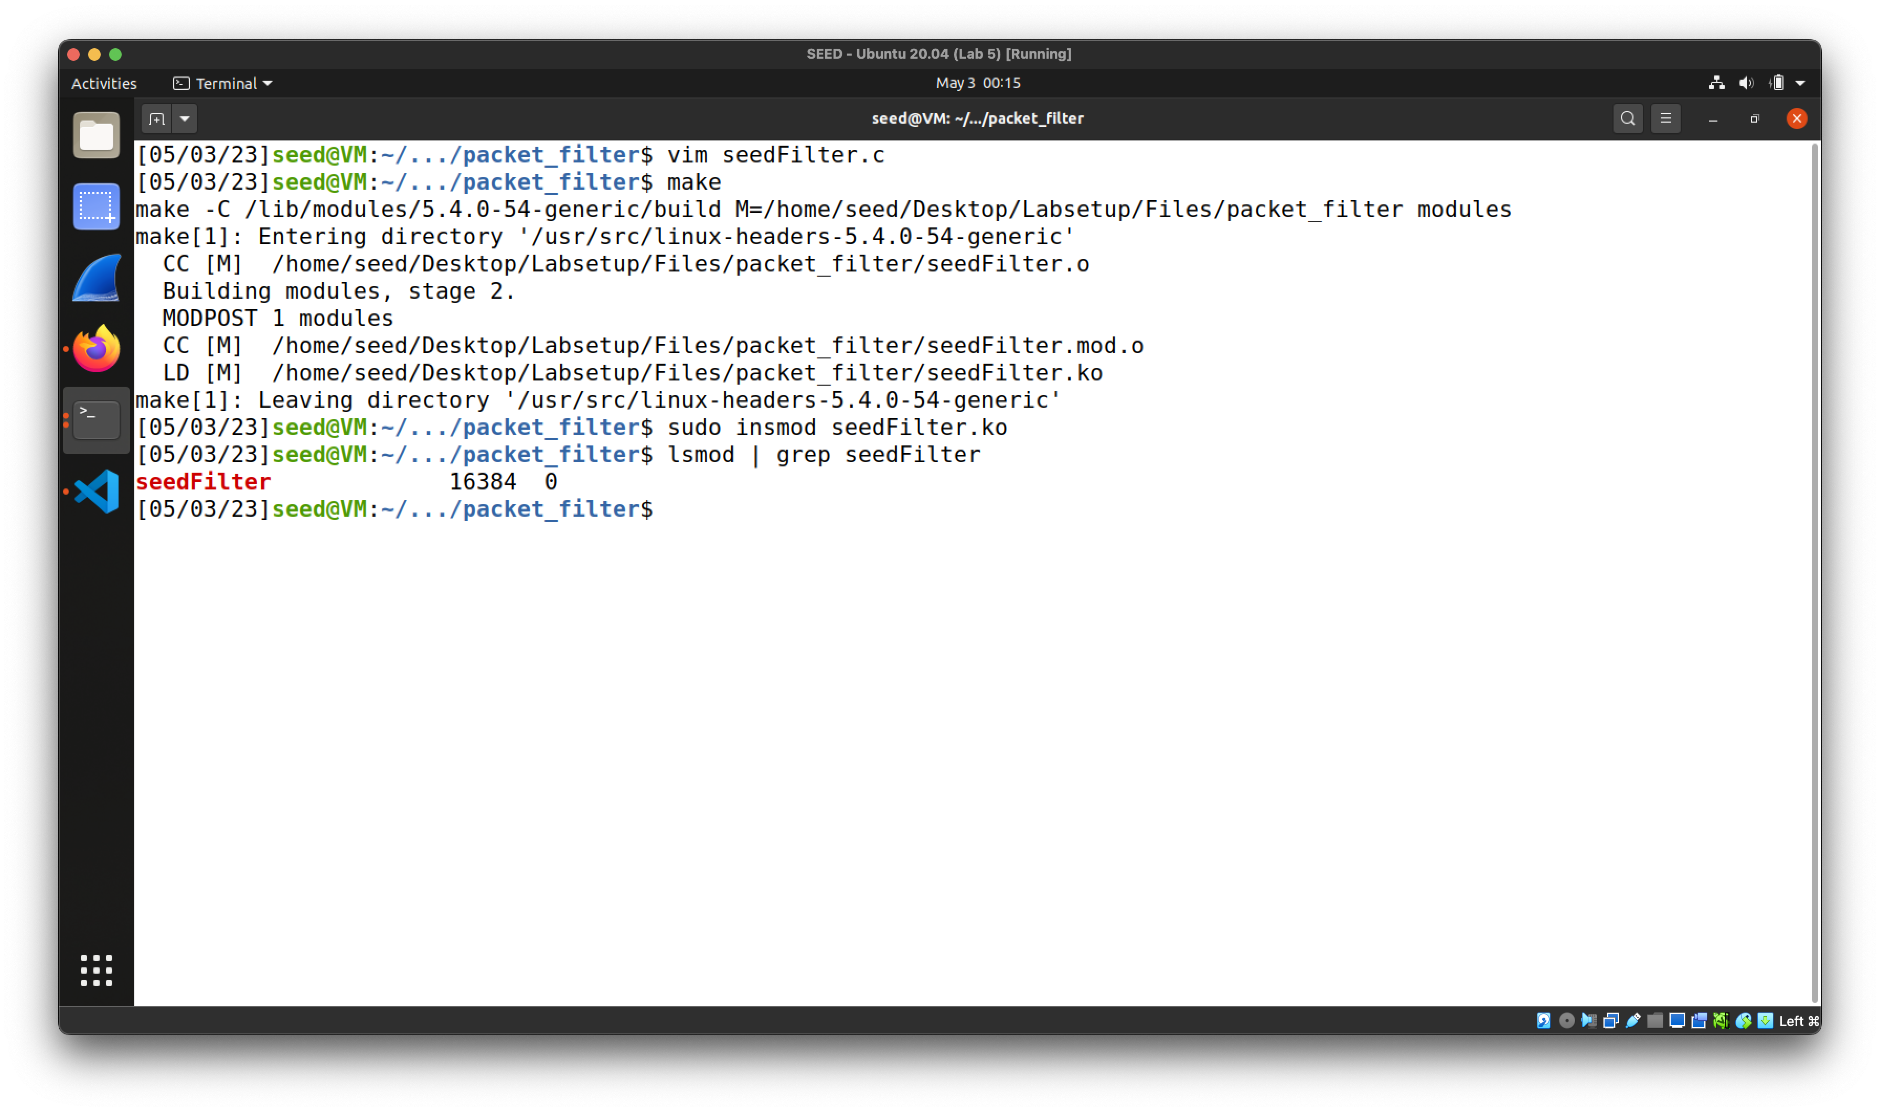

Compile and load.

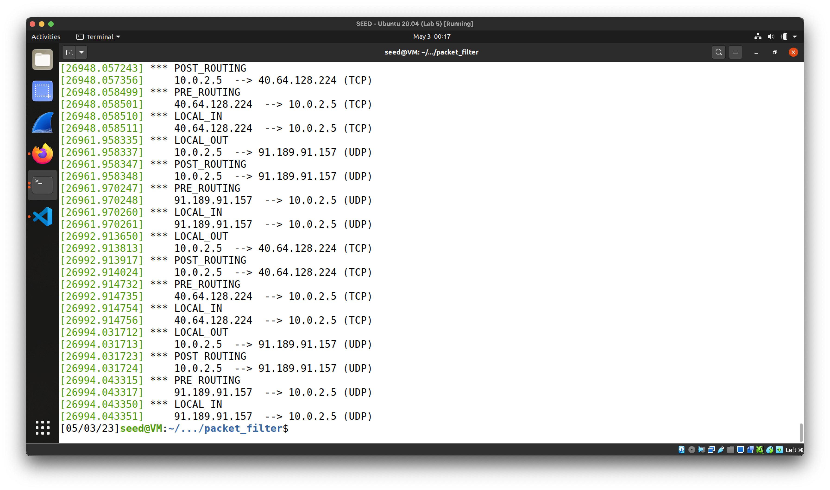

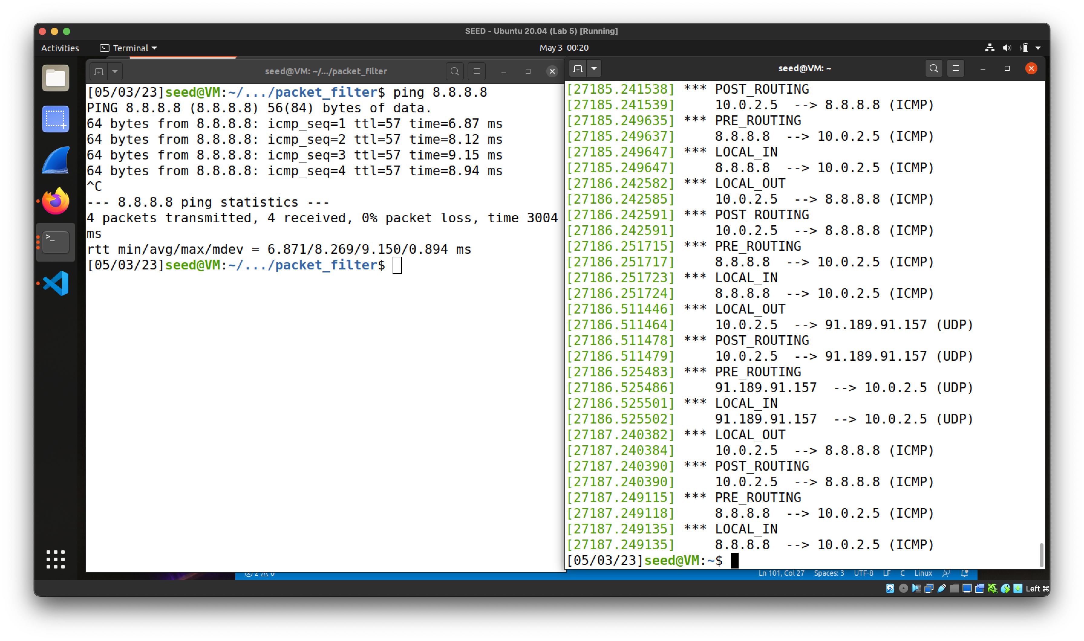

Print system log.

NF_INET_PRE_ROUTING, NF_INET_LOCAL_IN

* triggered when there is inbound traffic;
* PRE_ROUTING will be triggered first.

NF_INET_FORWARD

* trigger when there is traffic routed through the host.

NF_INET_LOCAL_OUT, NF_INET_POST_ROUTING

* triggered when there is outbound traffic;
* LOCAL_OUT will be triggered first.

**3.**

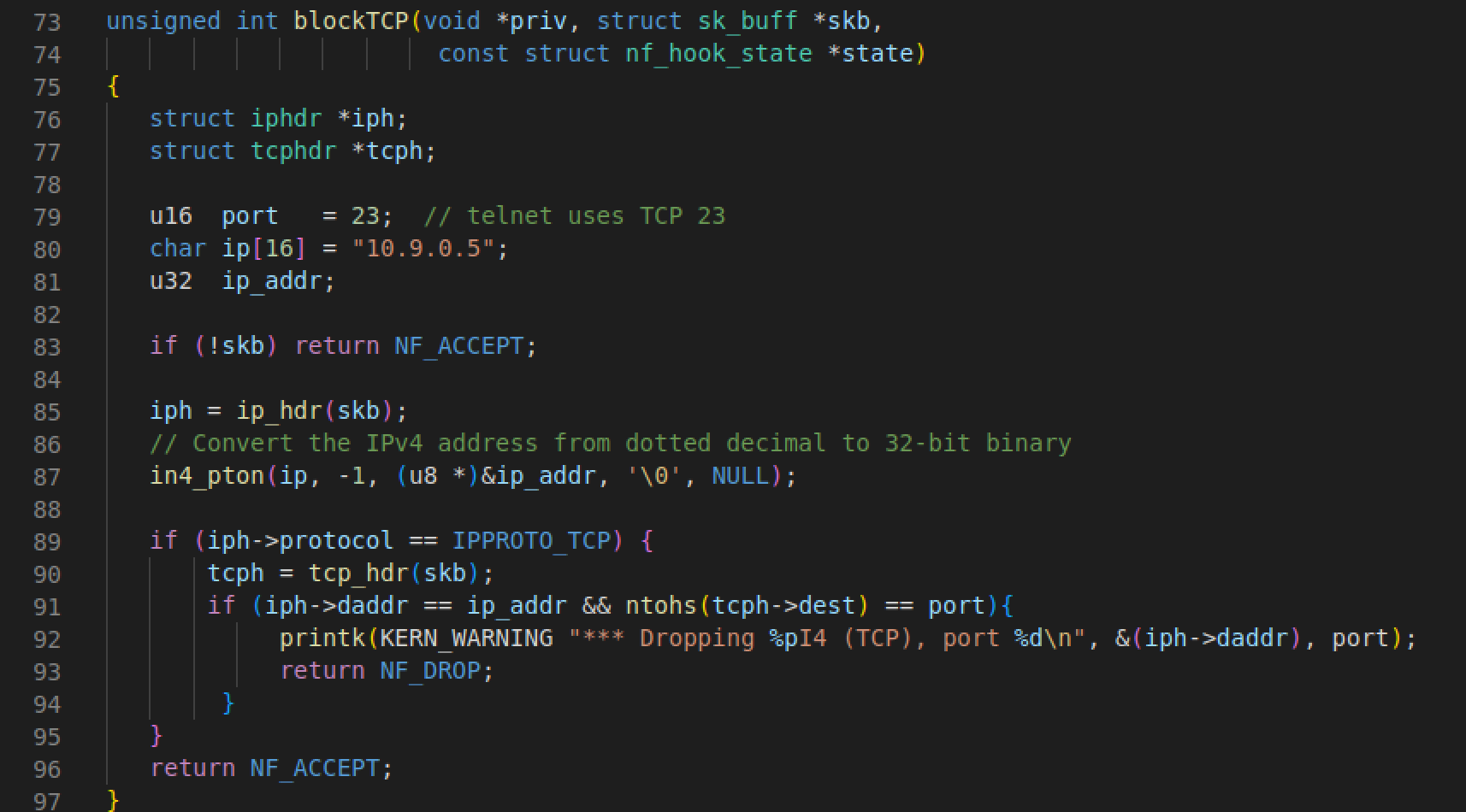

Function `blockTCP` written to block incoming Telnet traffic.

Hook to NF_INET_PRE_ROUTING.

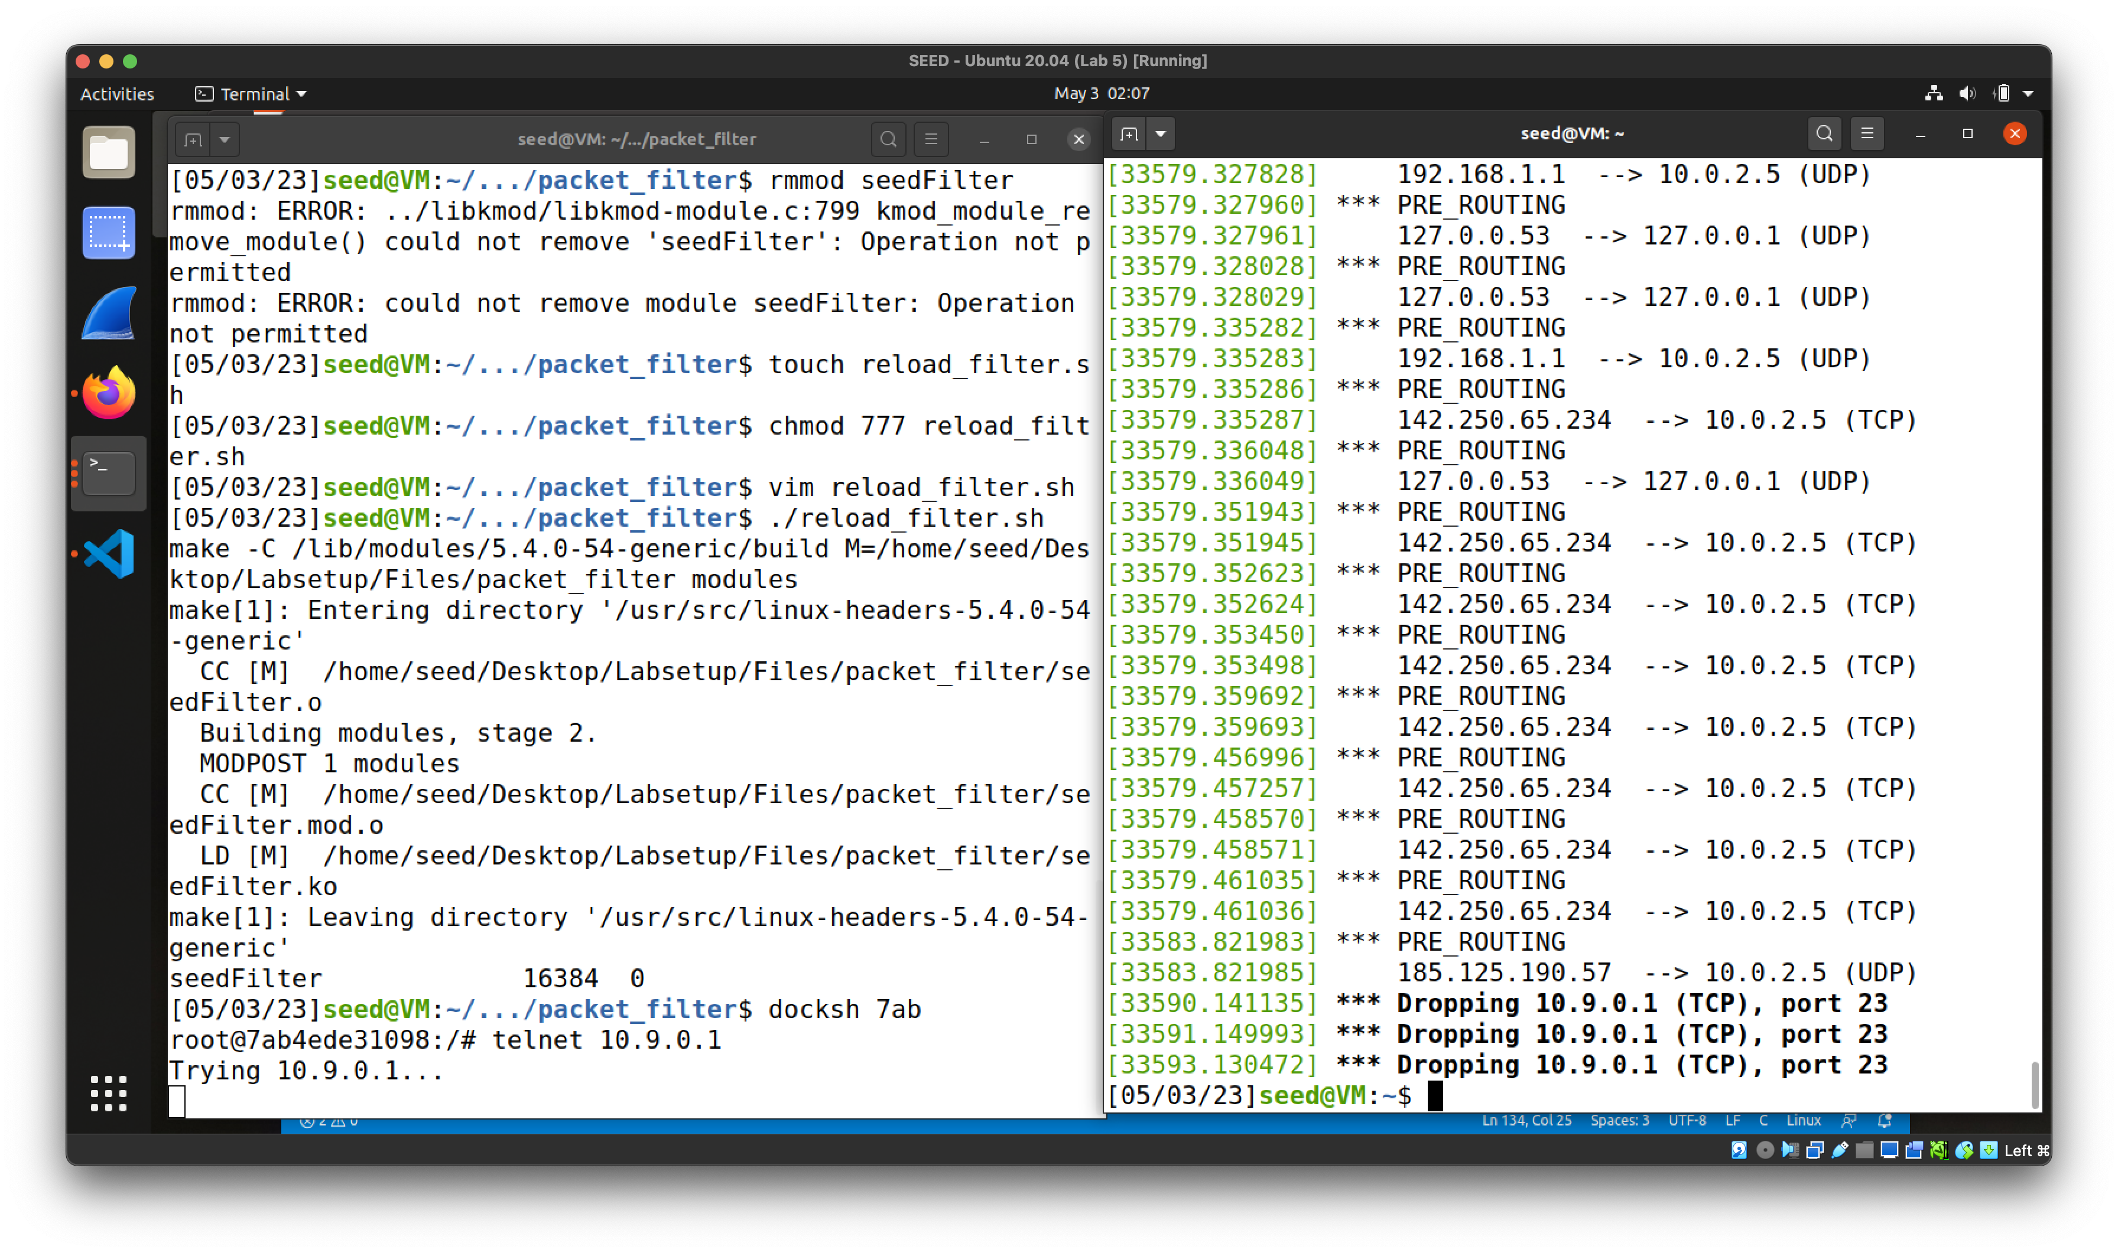

Telnet traffic dropped successfully.

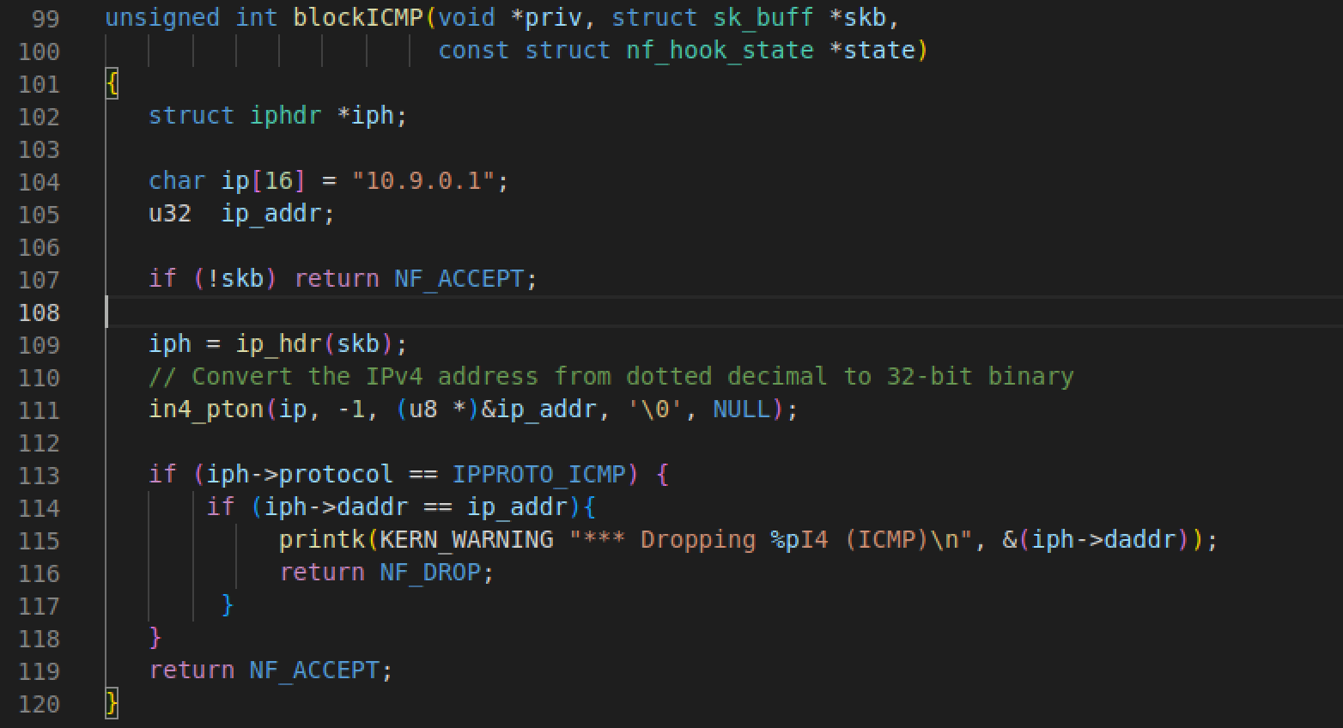

Function `blockICMP` written to block incoming ping traffic.

Hook to NF_INET_PRE_ROUTING.

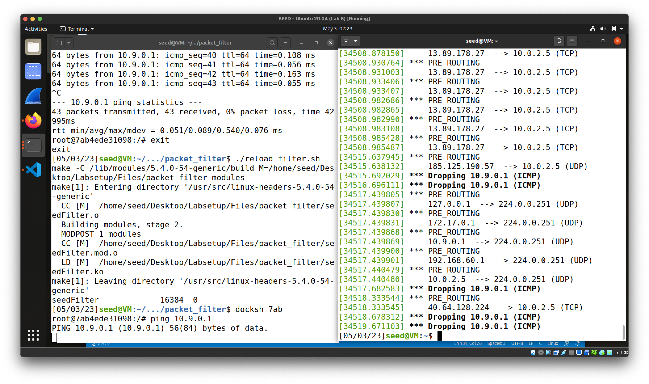

Ping would not go through.

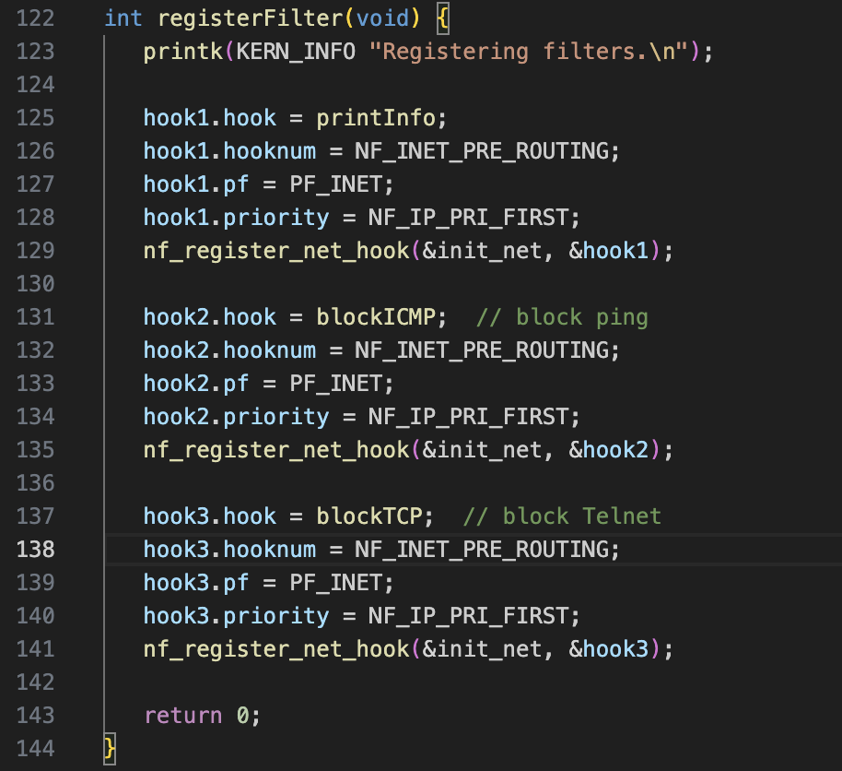

Hook registry.

**4.3 Protecting the Router**

**Task 2.A**

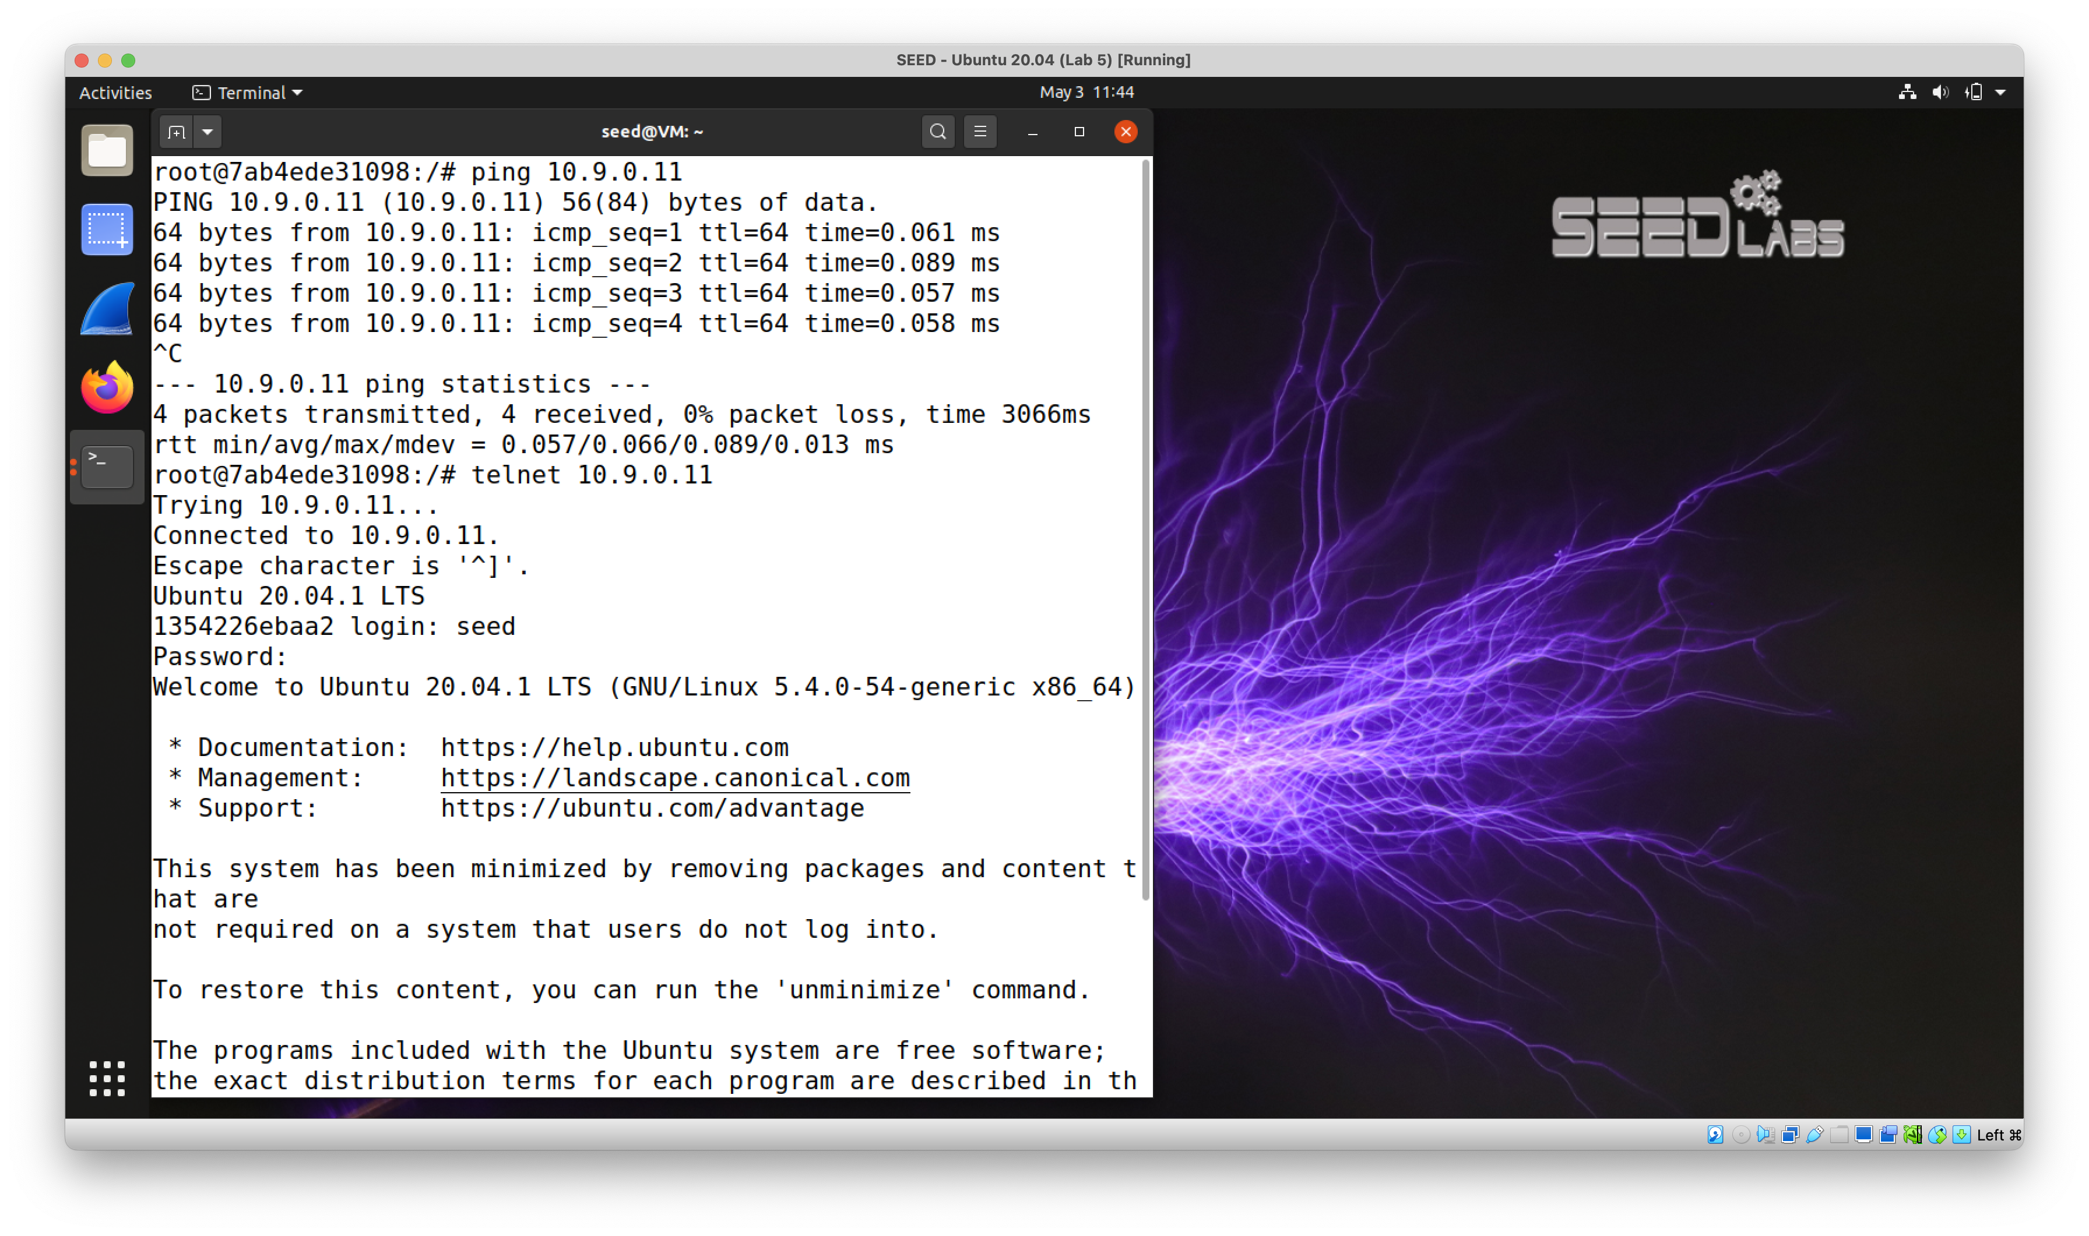

Before setting the rules, both ping and Telnet works.

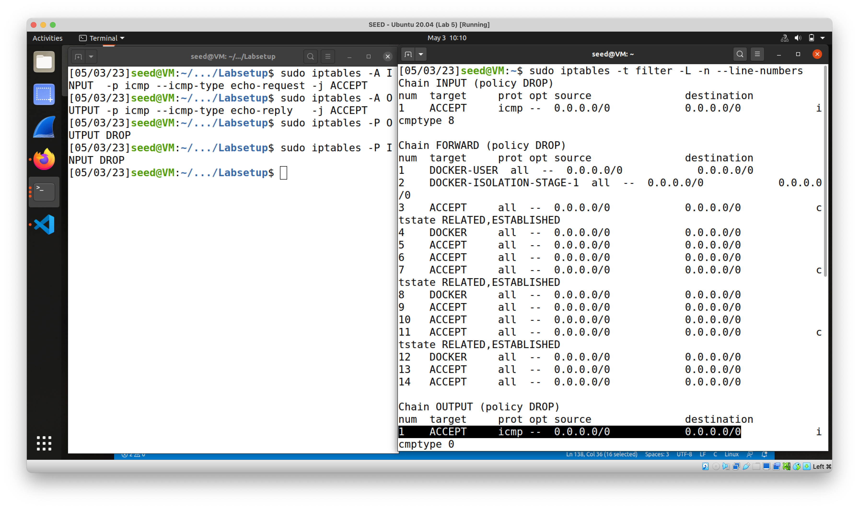

Set the iptables rule to host machine.

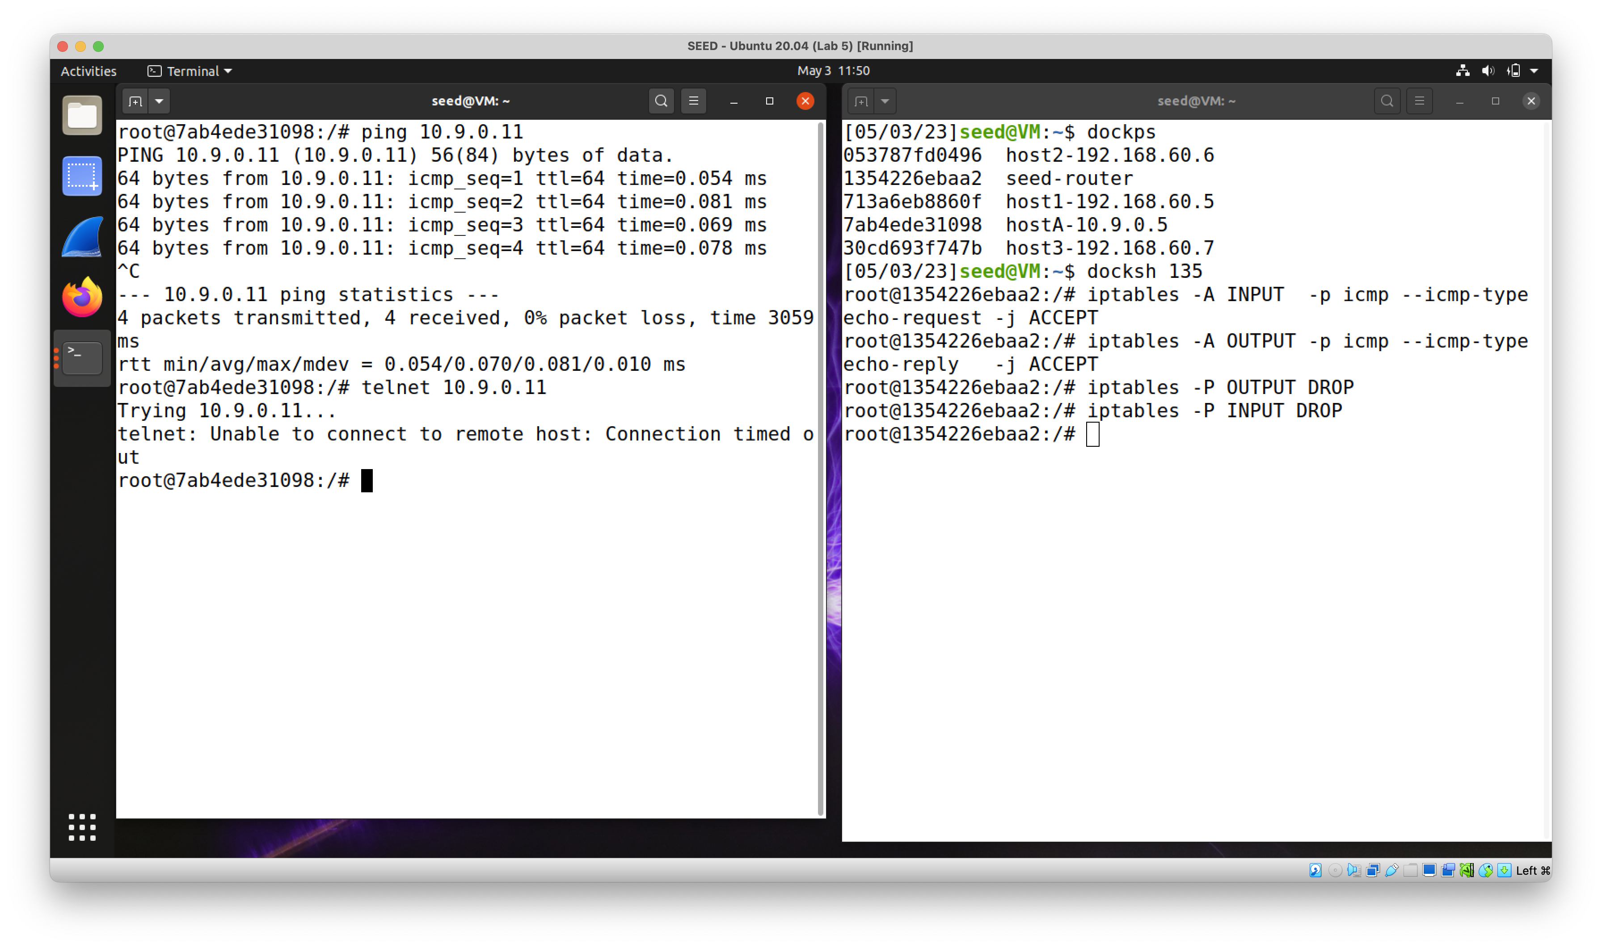

Ping works but Telnet won’t.

The first two rules allow pings, which uses ICMP echo requests and replies. The following two rules filters out anything that is not explicitly allowed.

**Task 2.B**

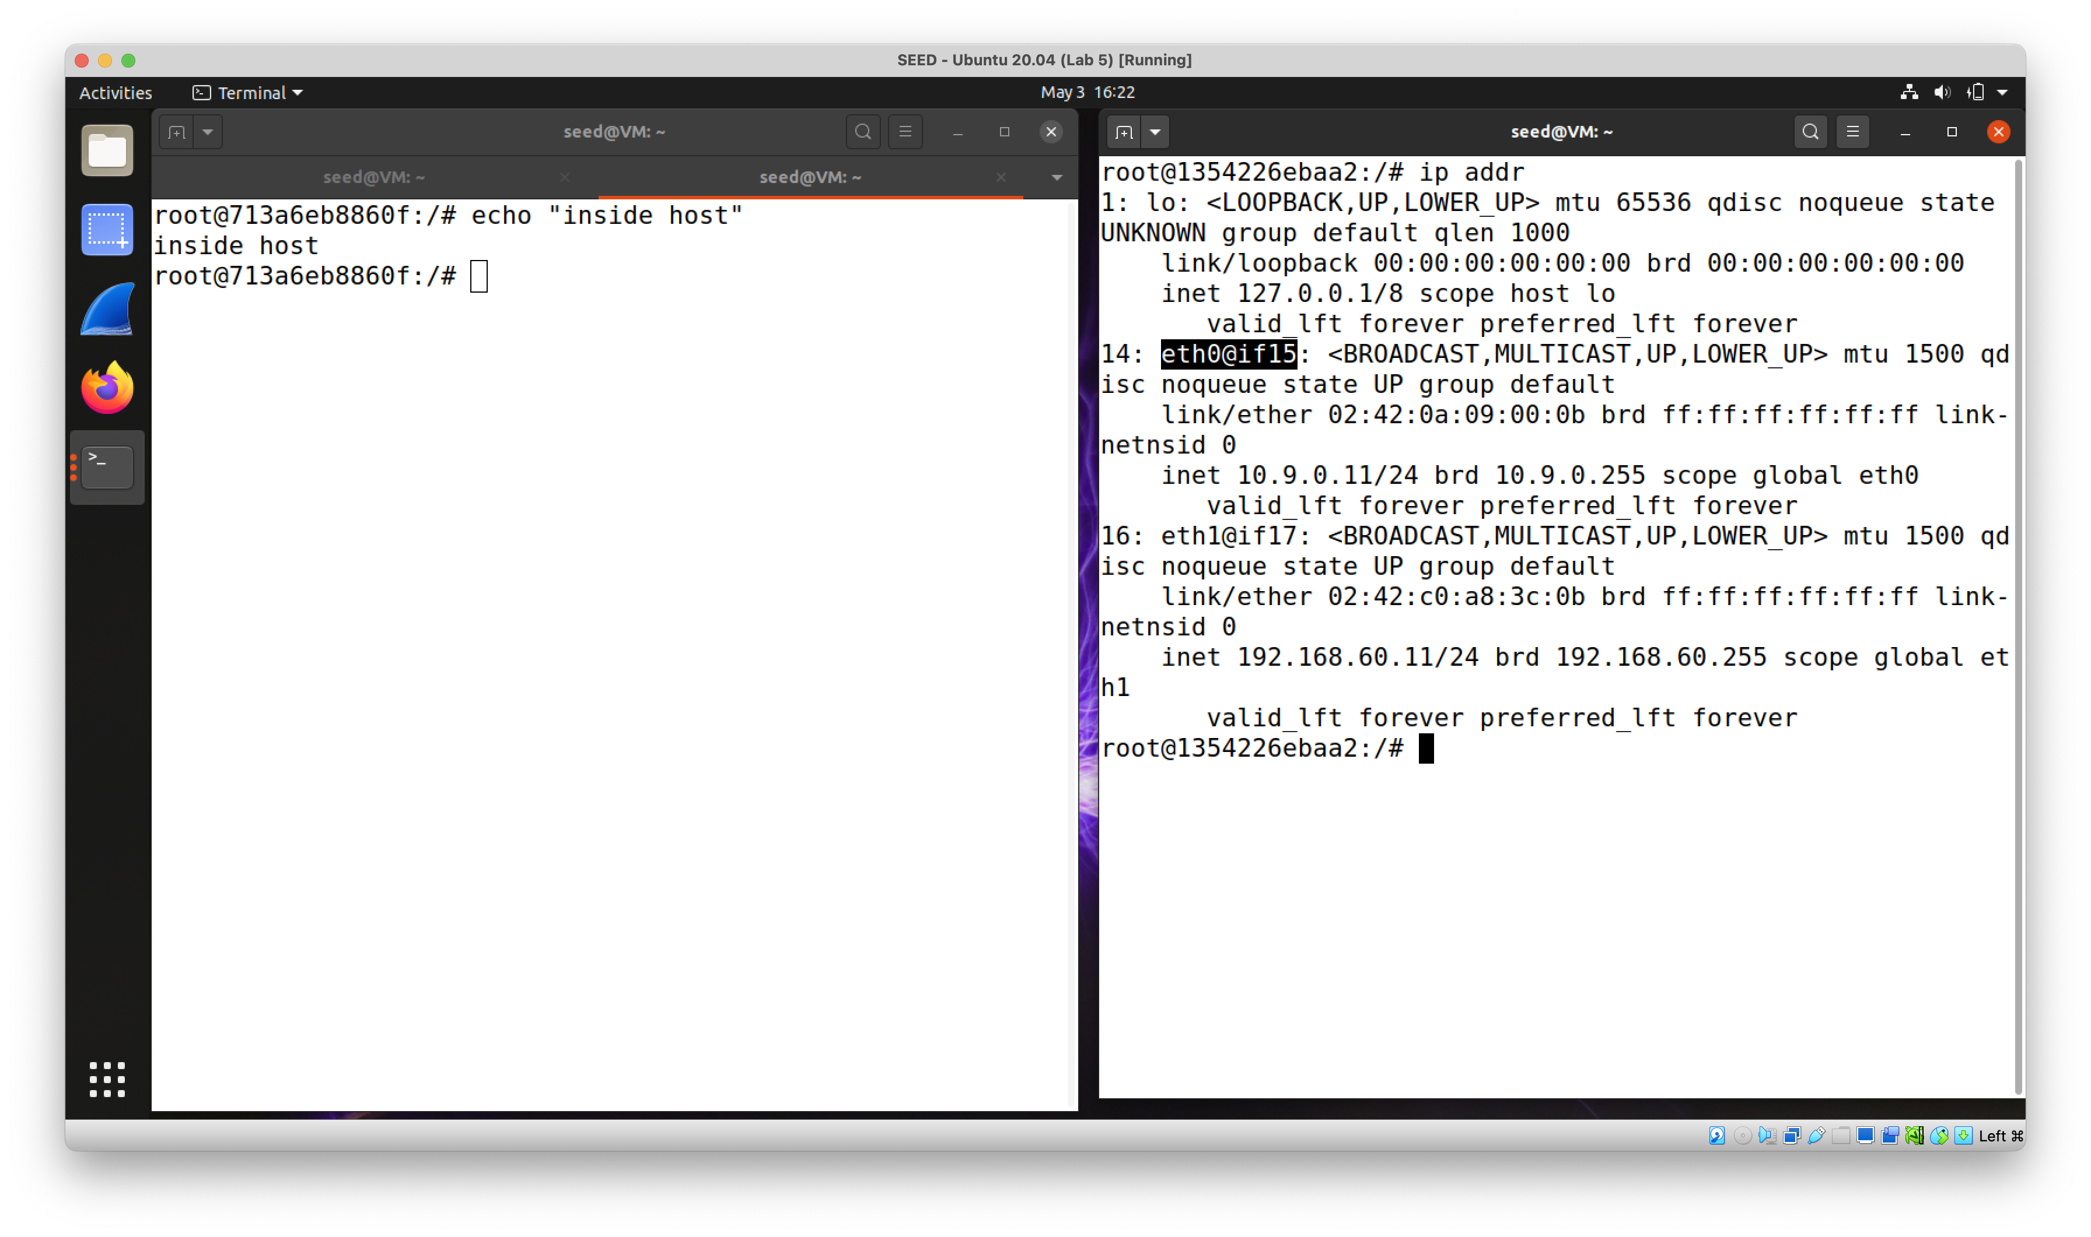

Router interface on the 10.9.0.0/24 network is eth0, and on the 192.168.60.0/24 network is eth1.

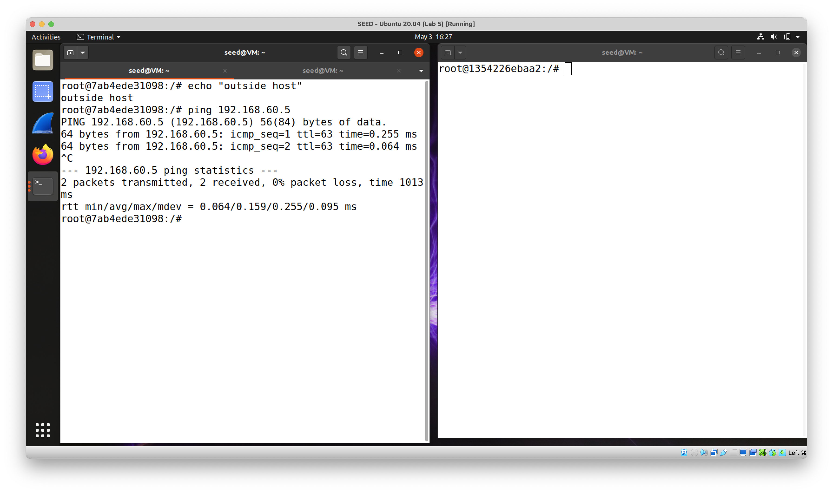

Outside host can ping inside host before any rule is set.

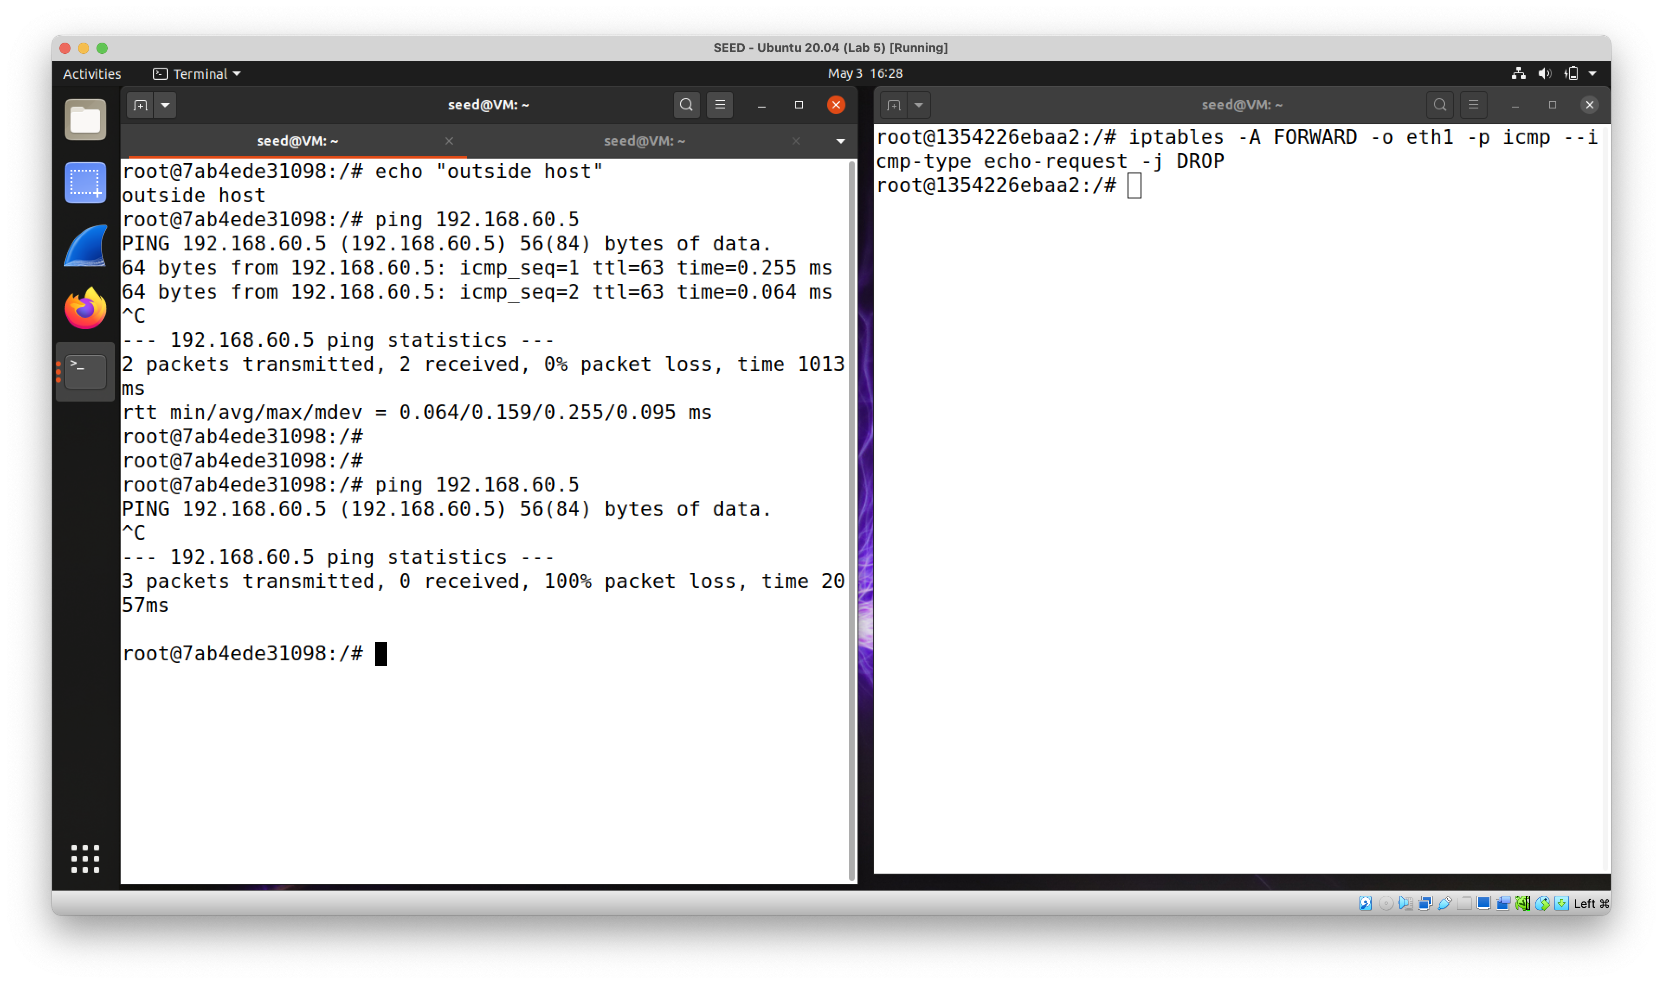

` iptables -A FORWARD -o eth1 -p icmp --icmp-type echo-request -j DROP `

Now outside ping to inside hosts would be dropped.

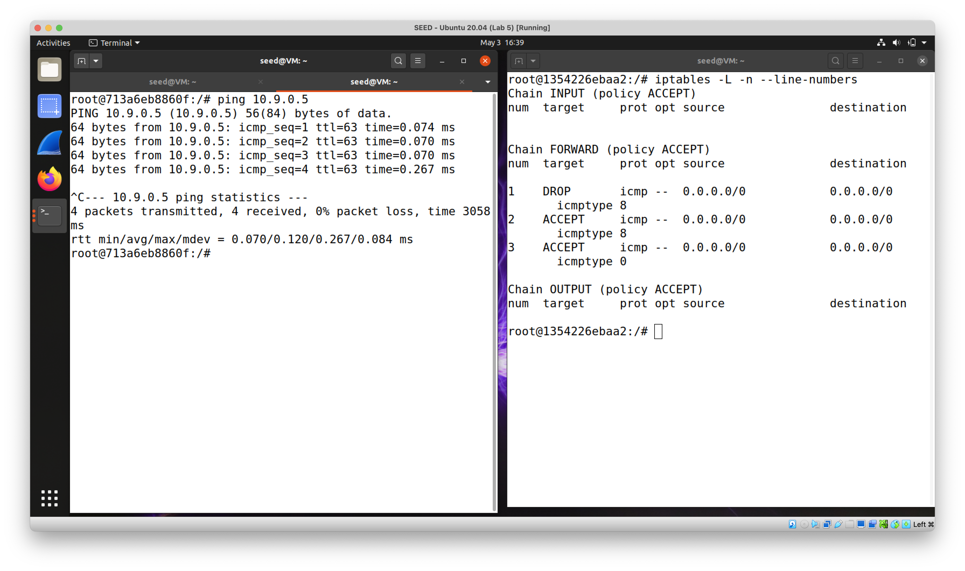

` iptables -A FORWARD -i eth1 -p icmp --icmp-type echo-request -j ACCEPT`

`iptables -A FORWARD -o eth1 -p icmp --icmp-type echo-reply -j ACCEPT `

Specifically allow inside hosts ping the outside.

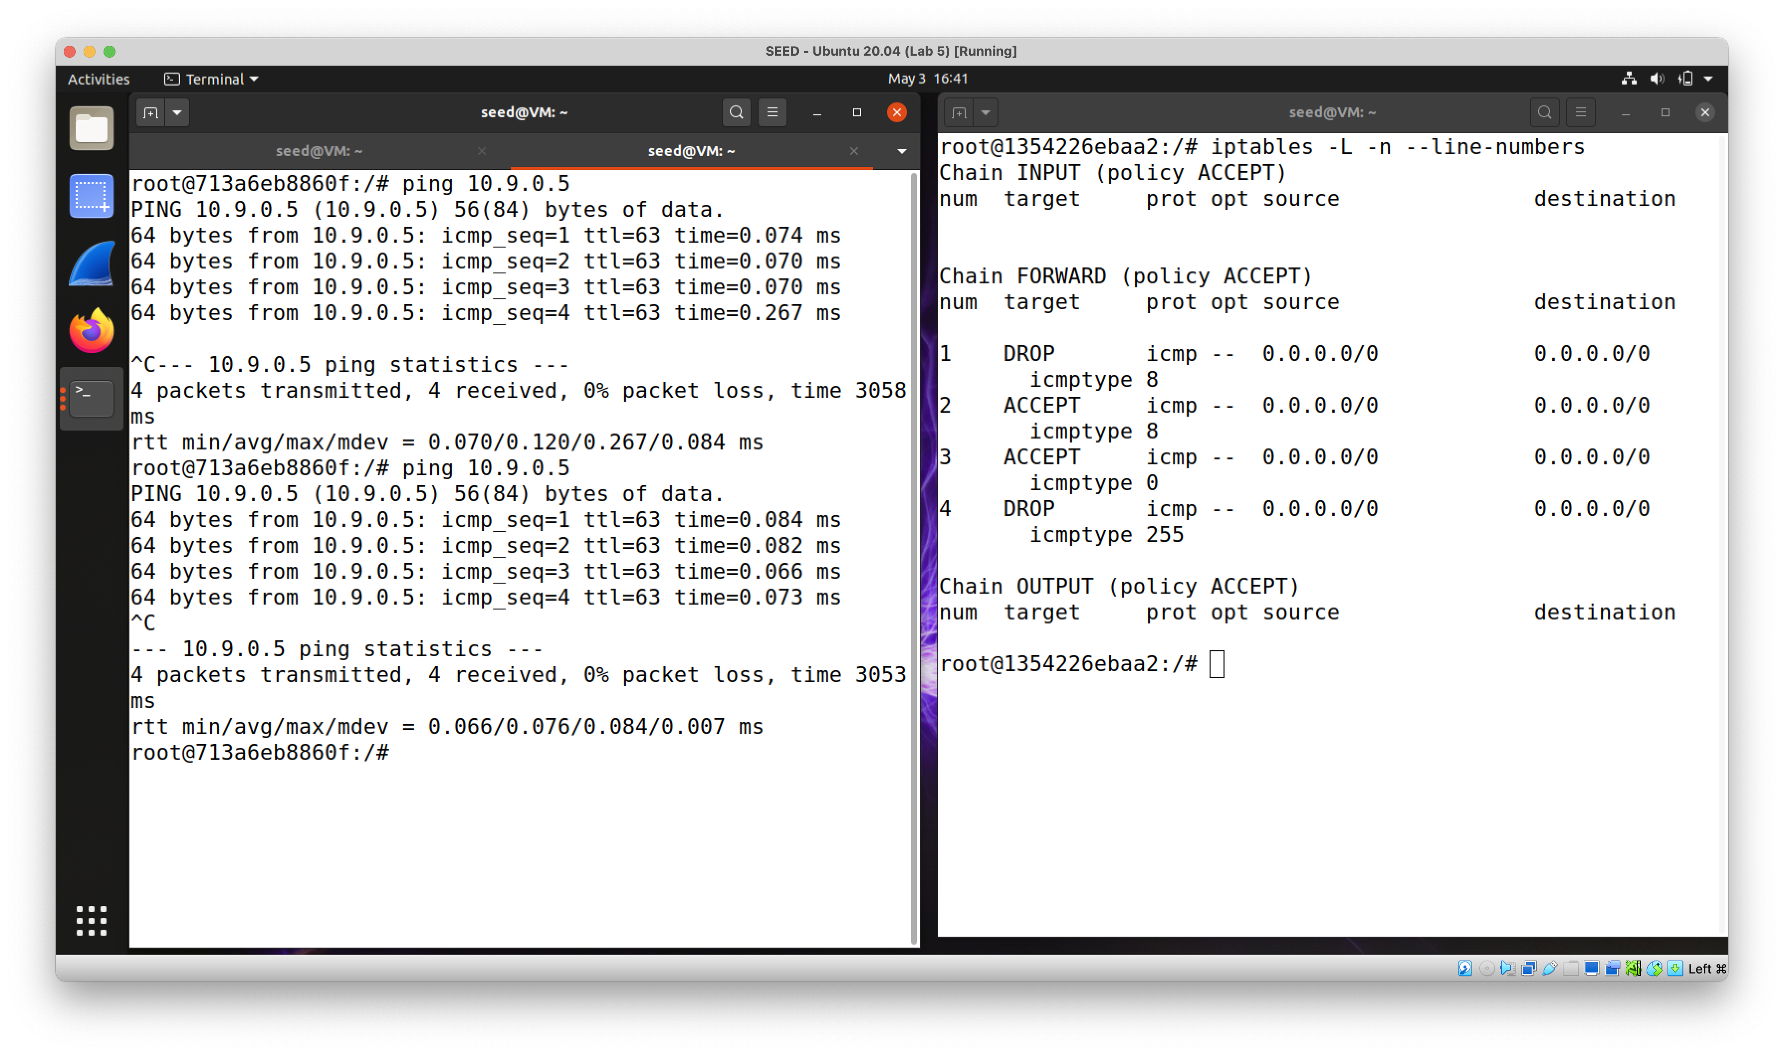

` iptables -A FORWARD -p icmp --icmp-type any -j DROP `

Drop anything not explicitly allowed. Inside hosts can still ping the outside.

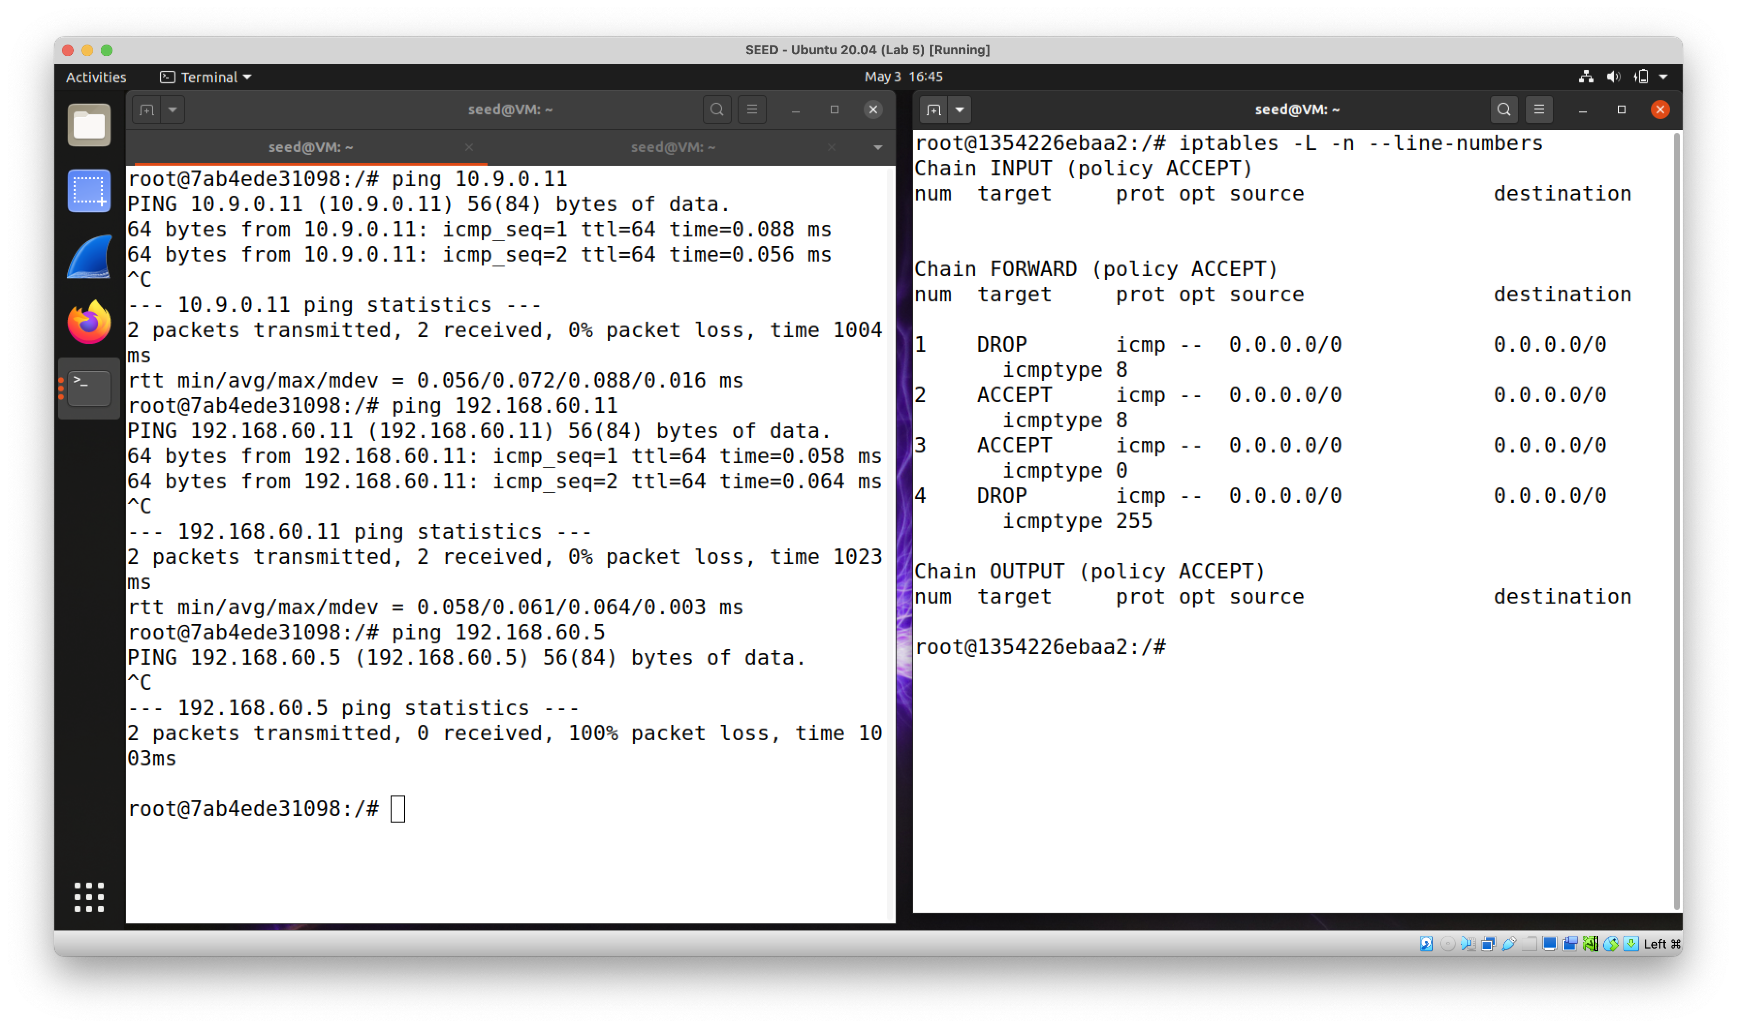

Outside hosts can ping the router but no inside hosts.

**Task 2.C**

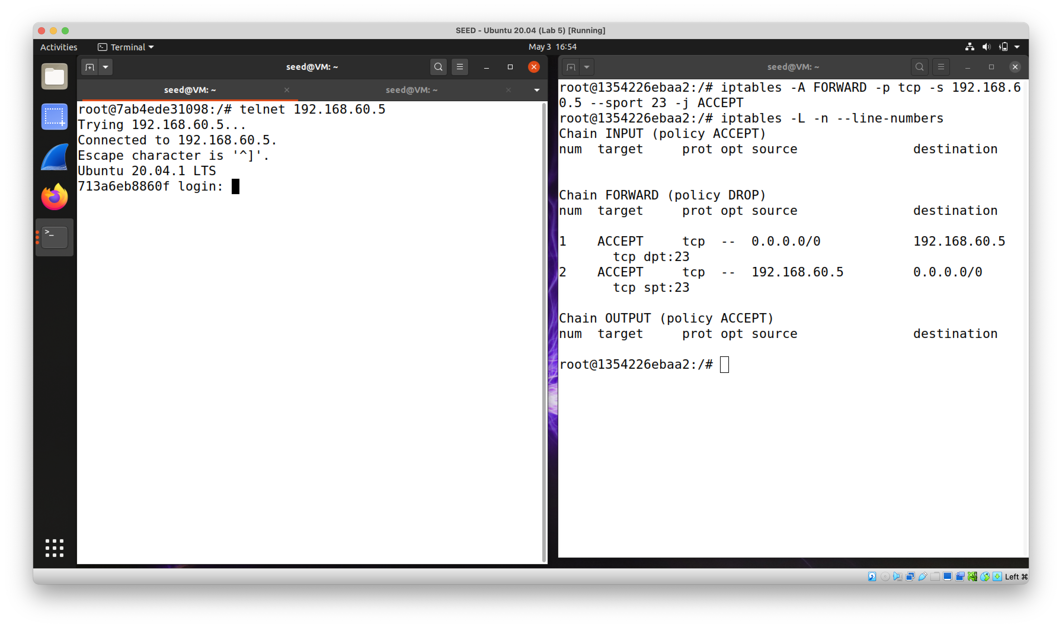

` iptables -A FORWARD -p tcp -d 192.168.60.5 --dport 23 -j ACCEPT `

Specially allow outside Telnet requests to 192.168.60.5, and response from 192.168.60.5.

` iptables -P FORWARD DROP `

Drop everything else.

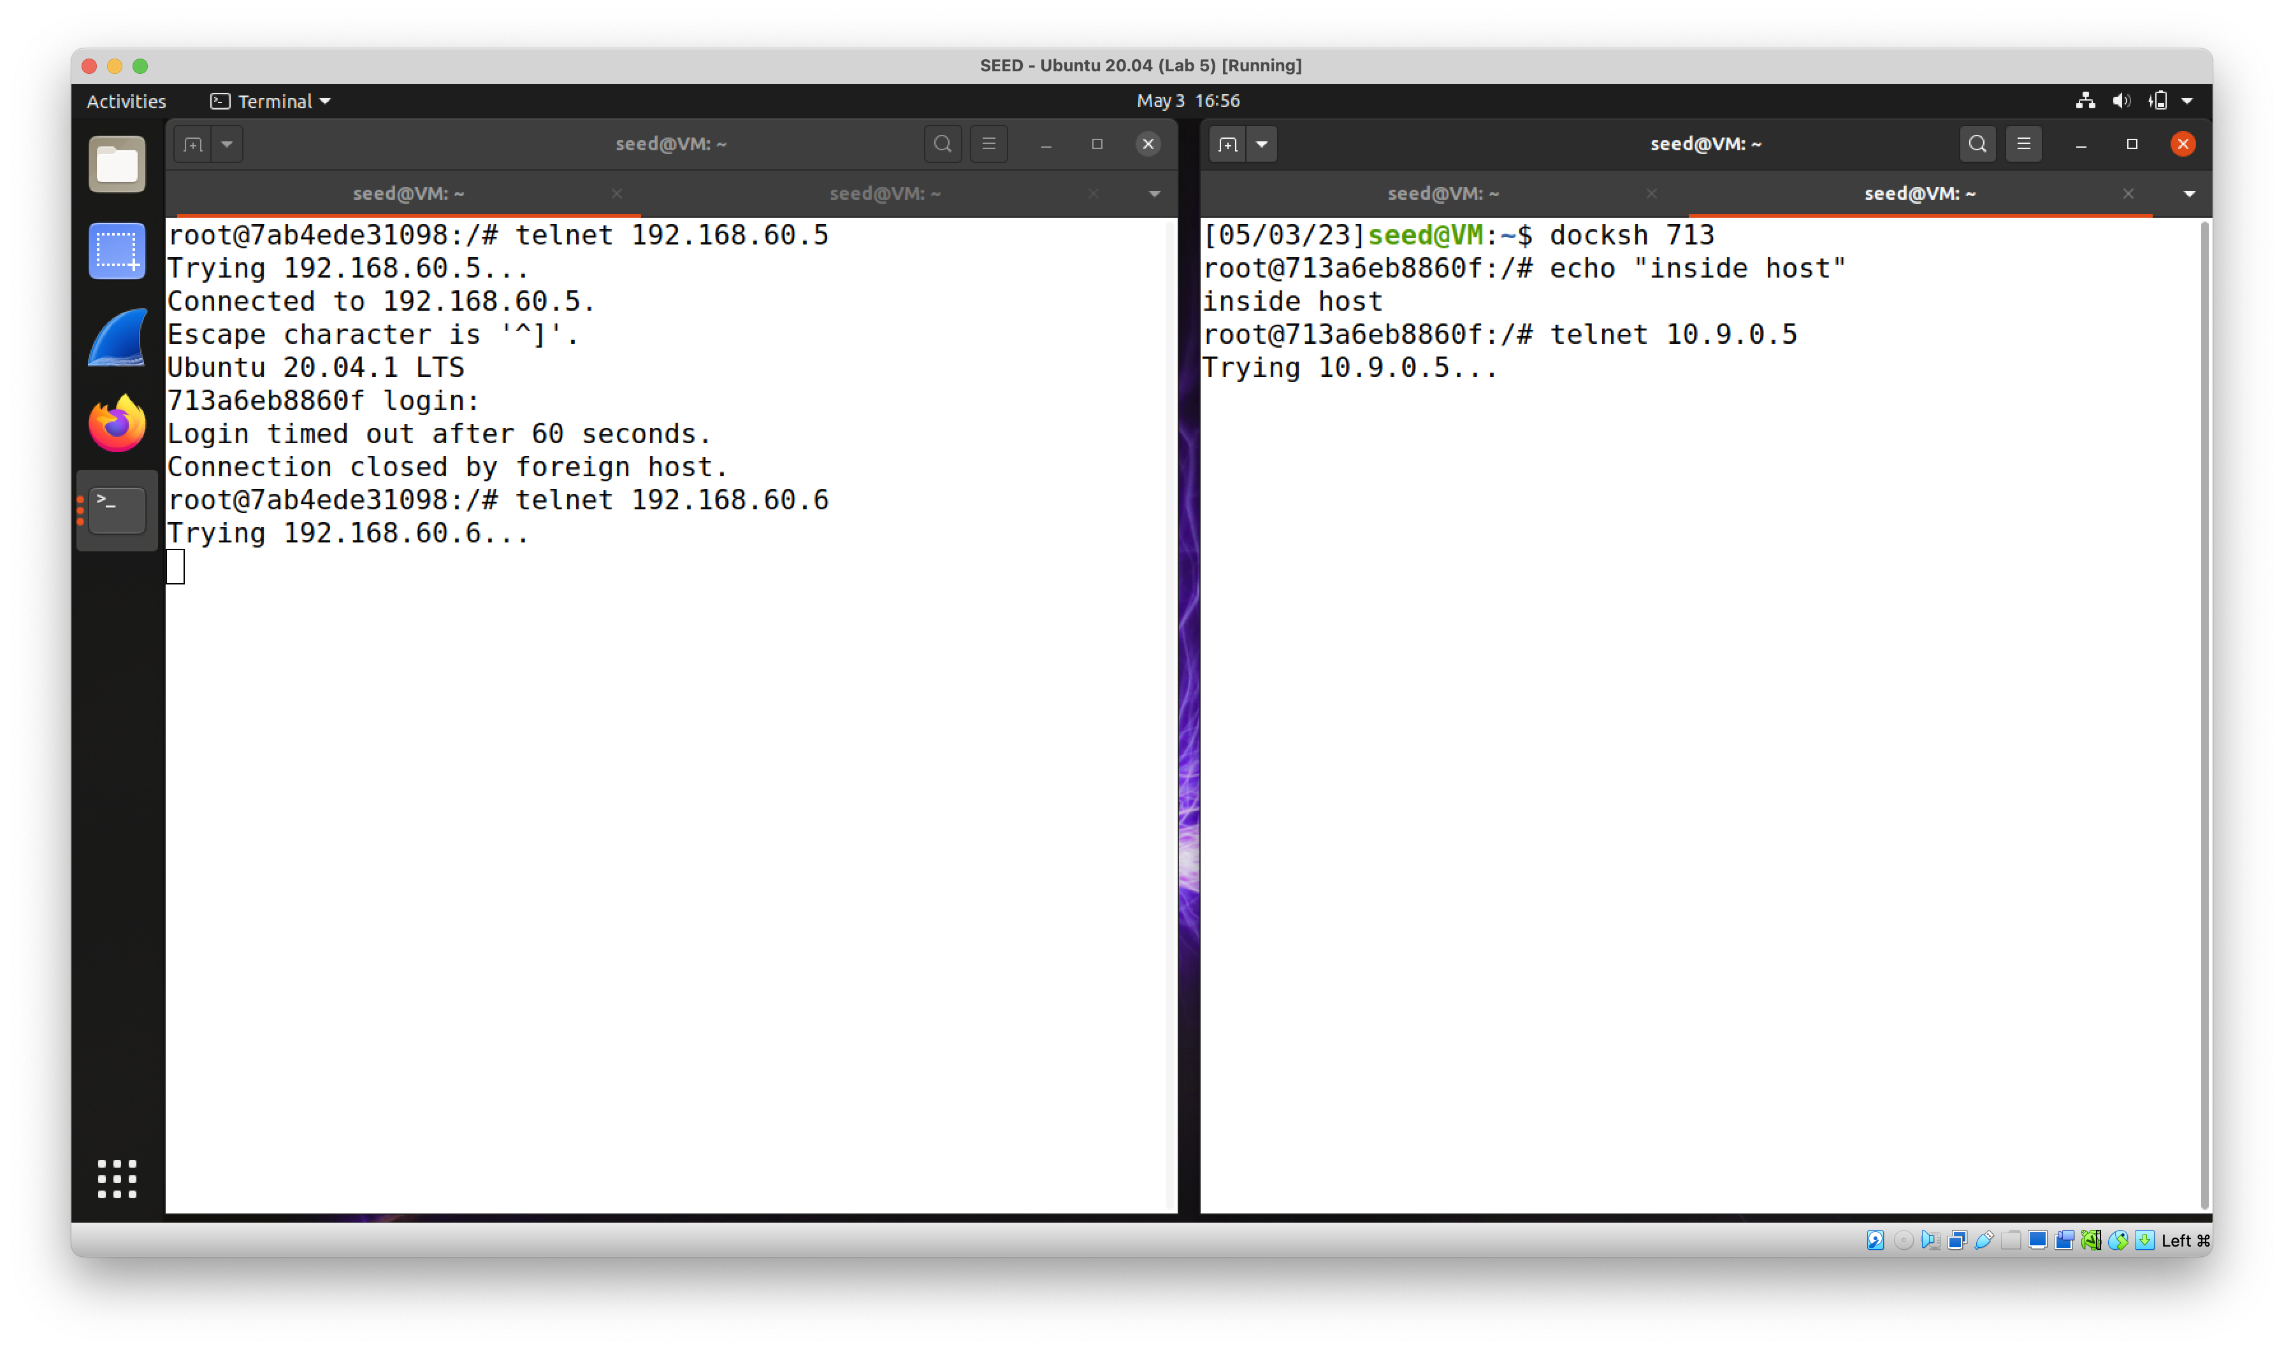

Outside hosts cannot Telnet the inside (except for 192.168.60.5), and inside hosts cannot Telnet the outside.

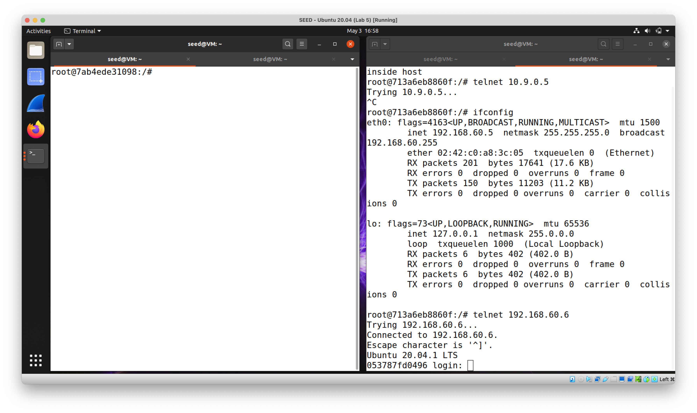

Telnet between inside hosts is fine.

**Task 3.A**

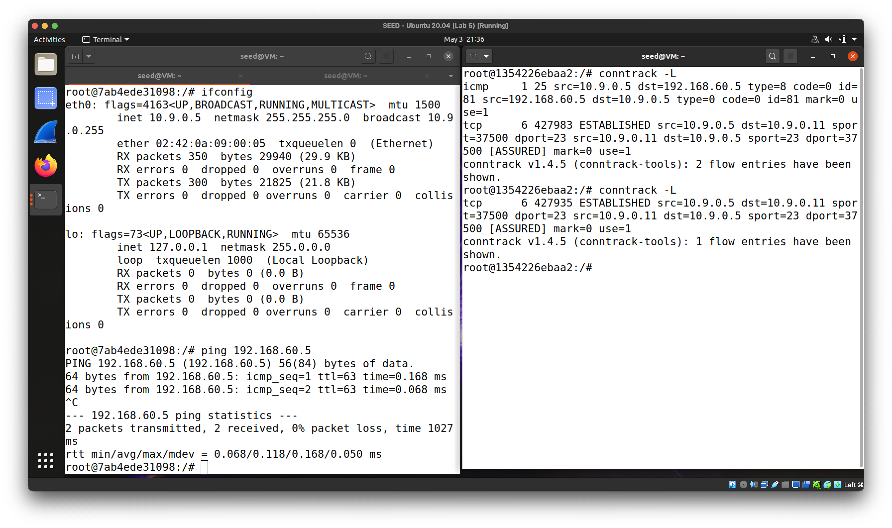

Ping traffic leaves an ICMP connection.

The ICMP connection disappears within 1 minute after the ping stops.

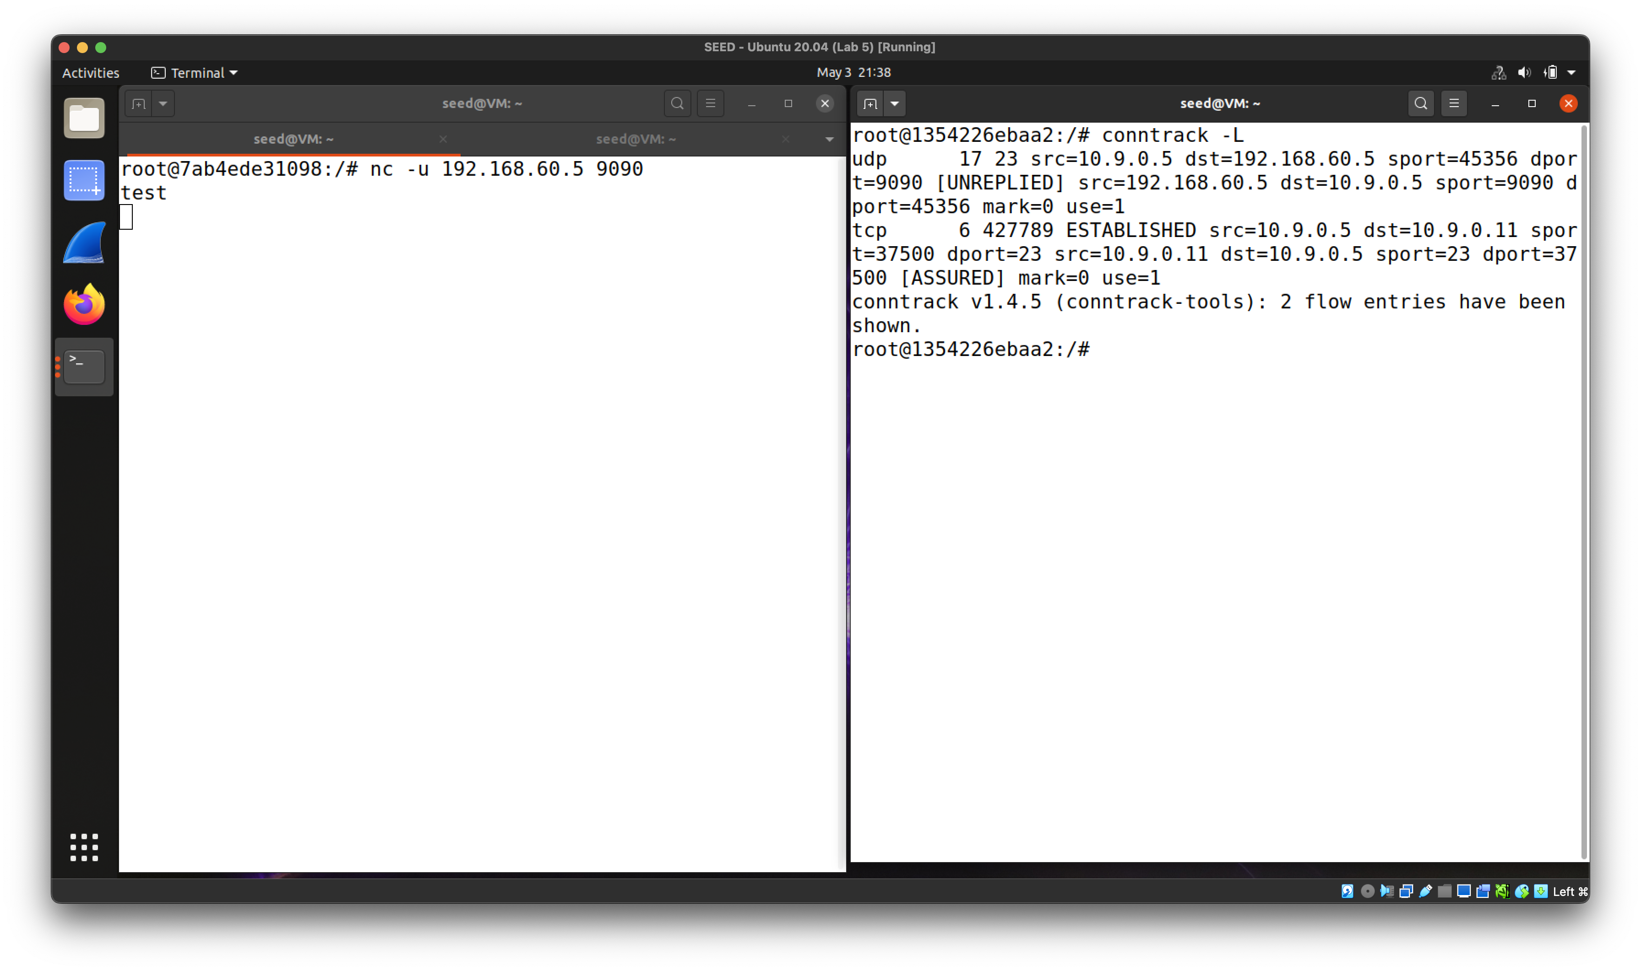

The UDP connection disappears within 1 minute after the last netcat message.

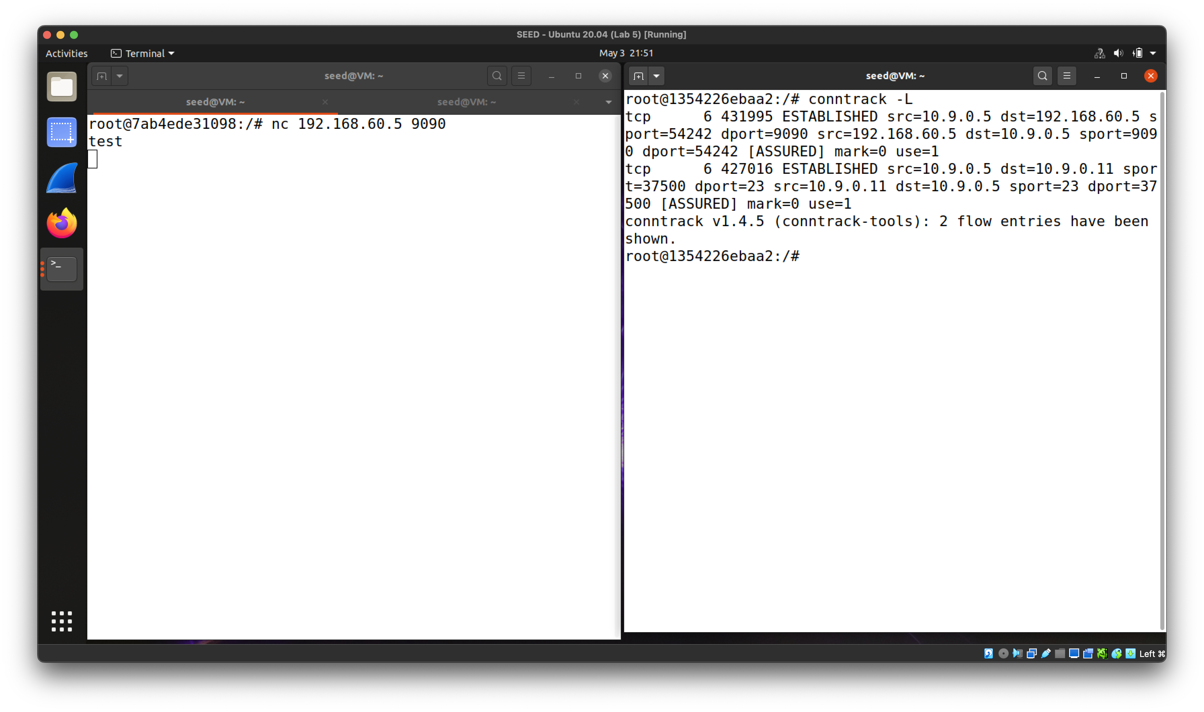

The TCP connection will not disappear until around 30 seconds after the netcat session is terminated.

**Task 3.B**

` iptables -A FORWARD -m conntrack --ctstate ESTABLISHED,RELATED -j ACCEPT`

`iptables -A FORWARD -i eth1 -m conntrack --ctstate NEW -j ACCEPT`

`iptables -A FORWARD -p tcp -i eth0 -d 192.168.60.5 --dport 23 --syn -m conntrack --ctstate NEW -j ACCEPT`

`iptables -P FORWARD DROP`

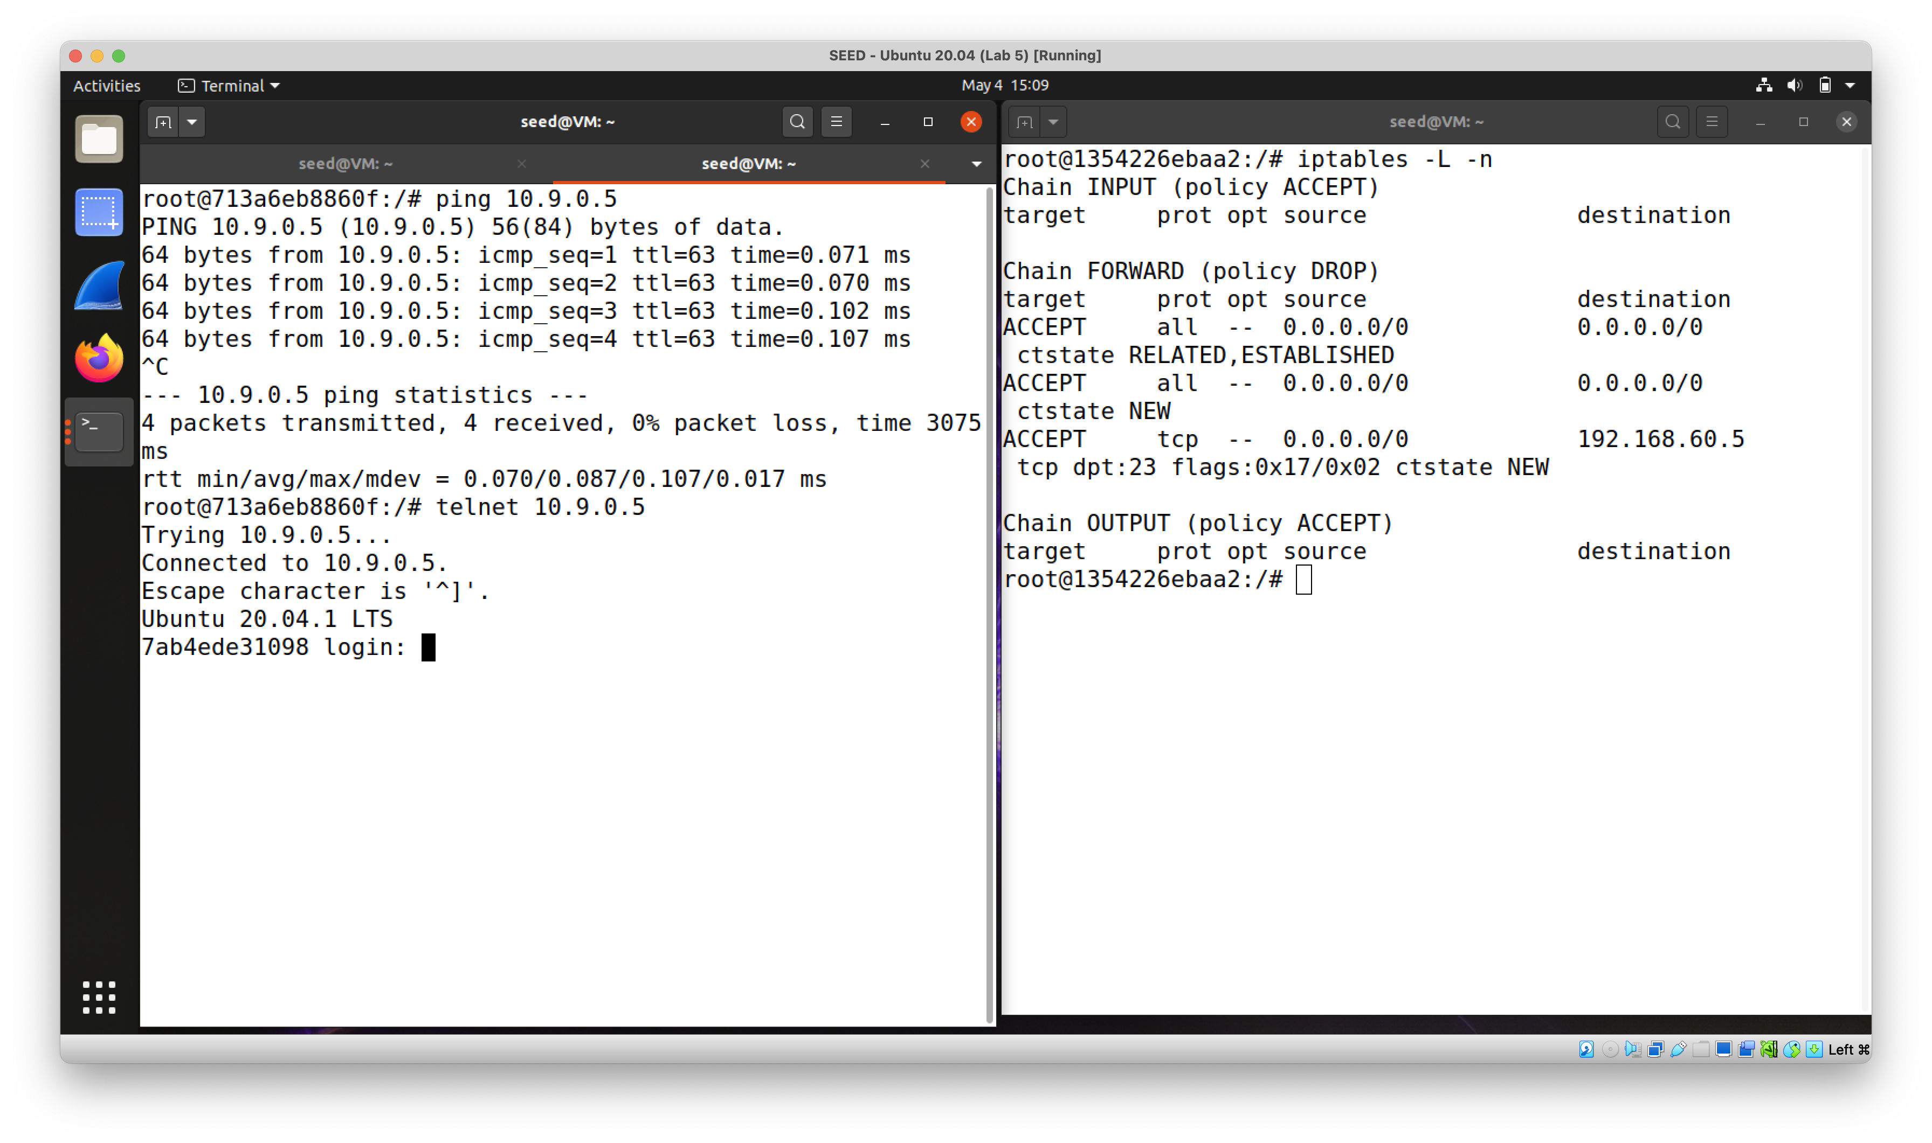

The traffic from inside hosts to the outside is allowed.

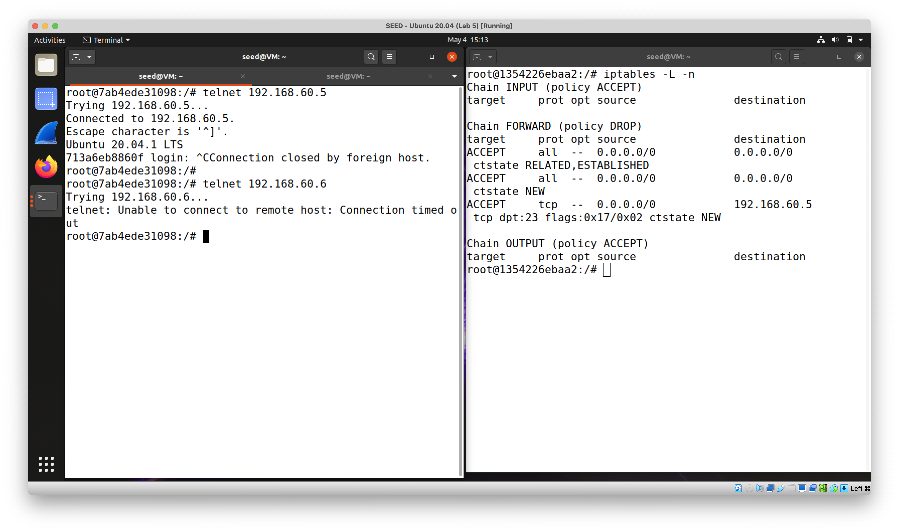

Telnet traffic from outside hosts to 192.168.60.5 is OK but not to other inside hosts.

Using a stateful firewall provides better protection against unsolicited traffic from outside hosts. It also simplifies the firewall rule configurations.

Without using a stateful firewall, the achievement of the same goal would probably require deeper inspection into each packet to tell apart unsolicited traffic from legit replies sent by outside hosts.

One of the disadvantages of using a stateful firewall would be the resource costs to maintain entries of connection in the memory.

**Task 4**

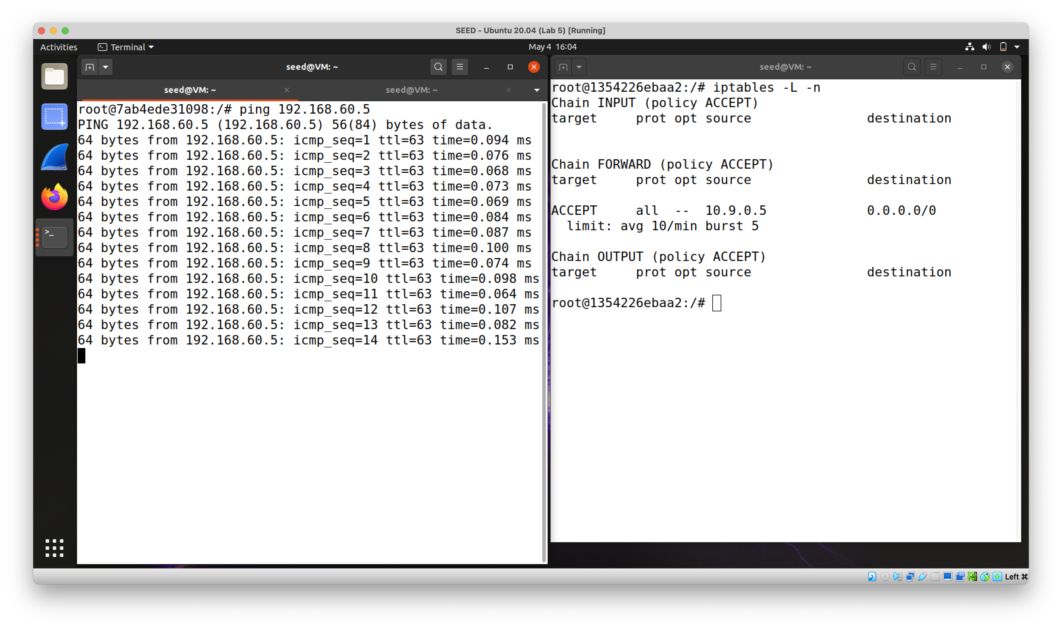

Without the second rule, 10.9.0.5 can ping 192.168.60.5 without limitations.

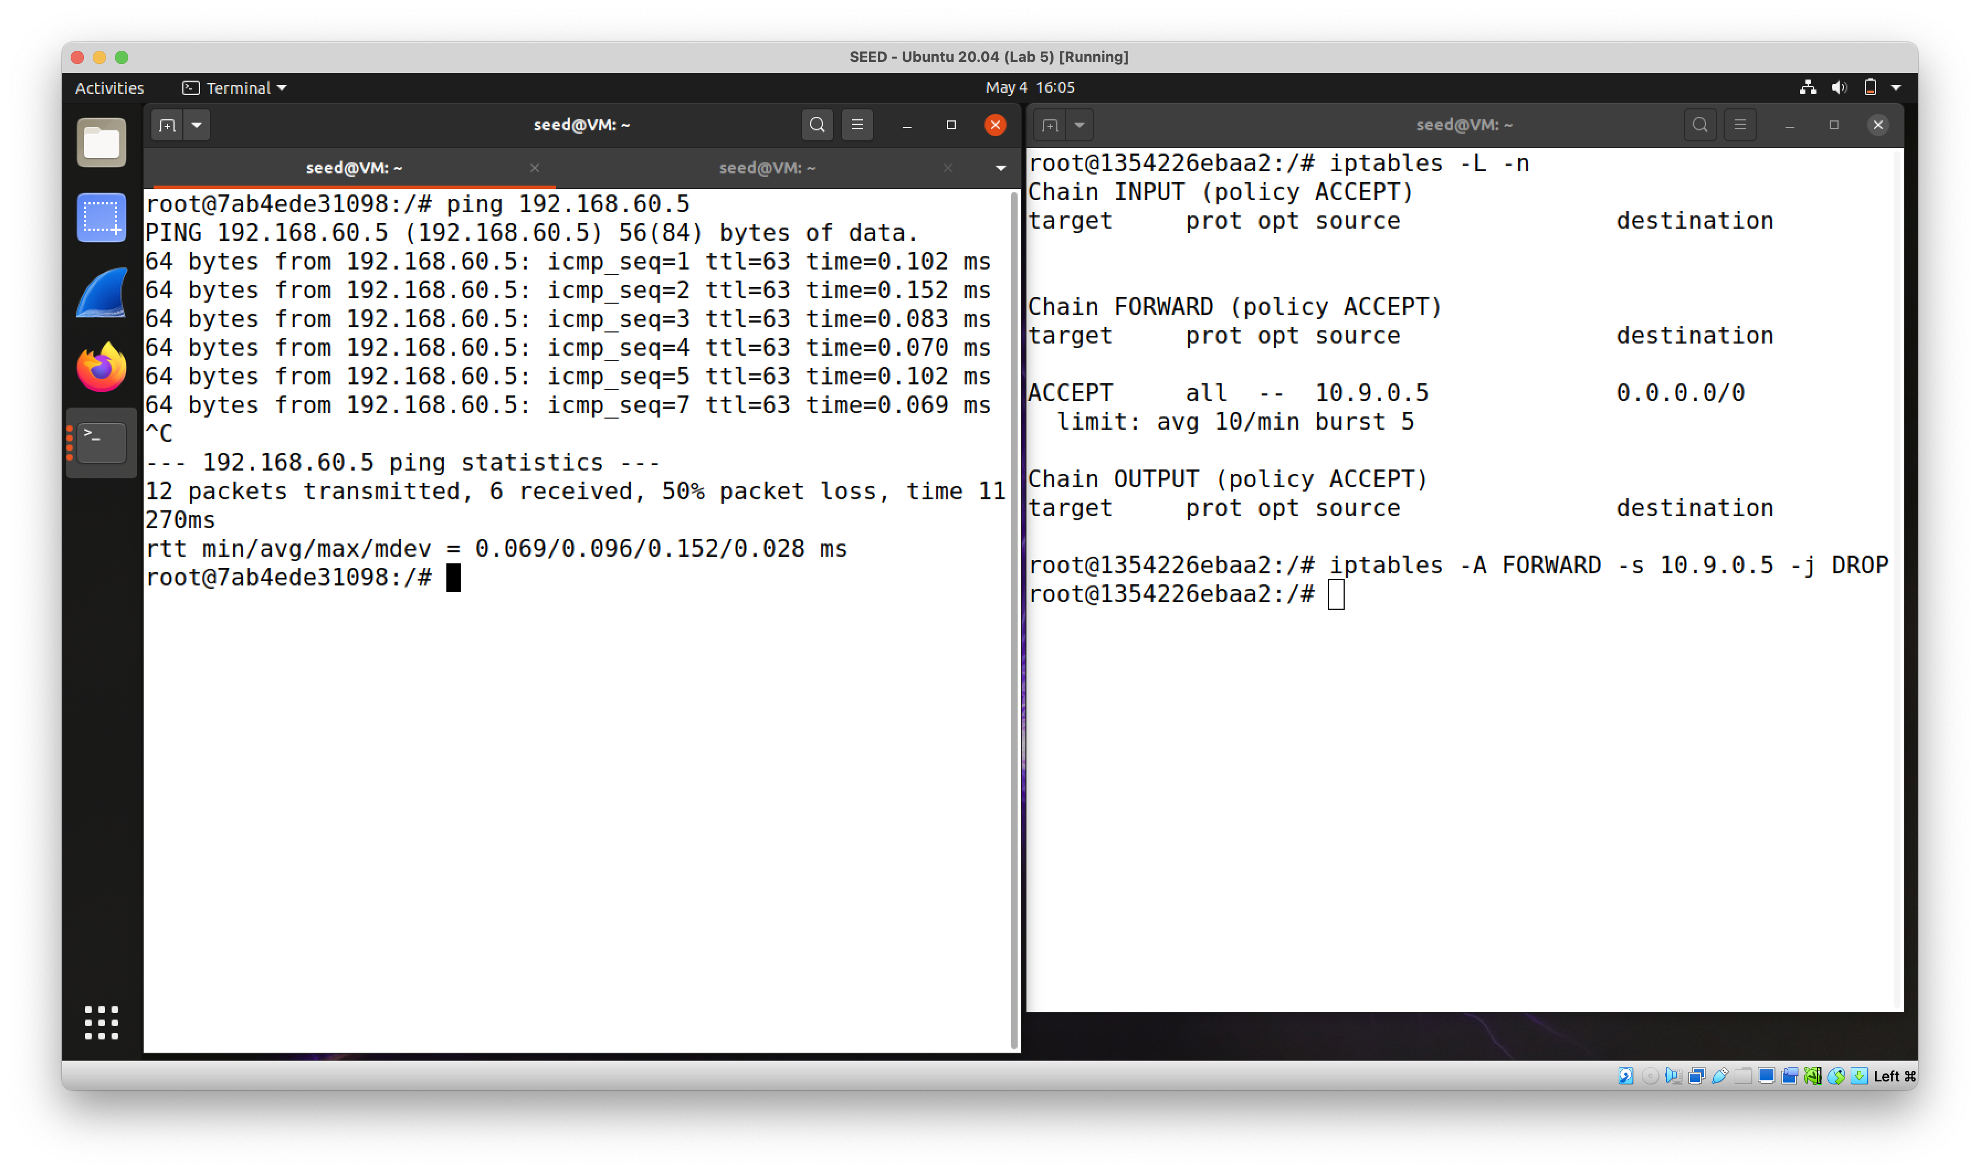

With the second rule, ping traffic from 10.9.0.5 to 192.168.60.5 is limited.

This is because traffic that does not fall into the first rules will follow the default (second) rule and be dropped.

**Task 5**

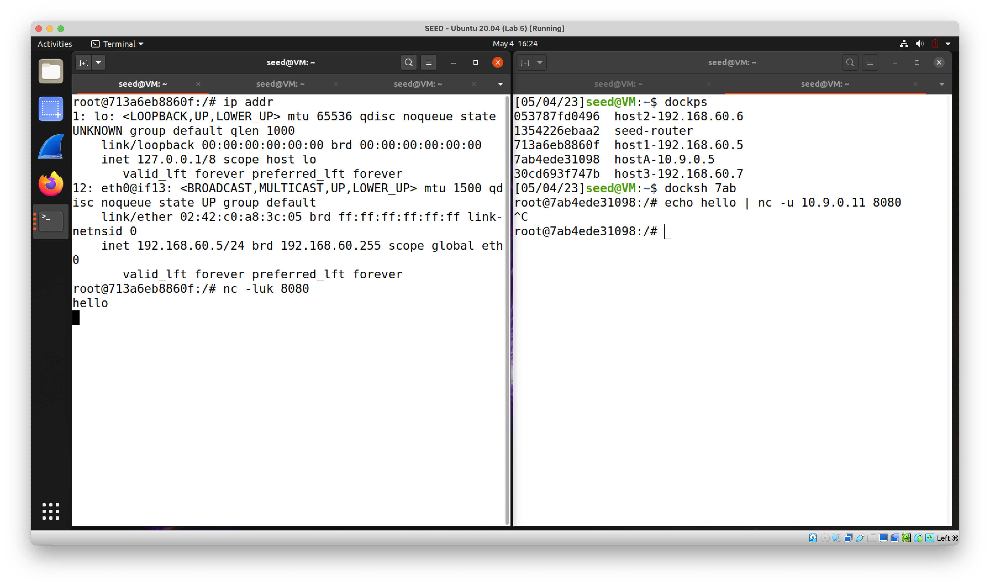

Traffic sent to the router is delivered to 192.168.60.5.

`iptables -t nat -A PREROUTING -p udp --dport 8080 -m statistic --mode nth --every 3 --packet 0 -j DNAT --to-destination 192.168.60.5:8080`

`iptables -t nat -A PREROUTING -p udp --dport 8080 -m statistic --mode nth --every 3 --packet 1 -j DNAT --to-destination 192.168.60.6:8080`

`iptables -t nat -A PREROUTING -p udp --dport 8080 -m statistic --mode nth --every 3 --packet 2 -j DNAT --to-destination 192.168.60.7:8080`

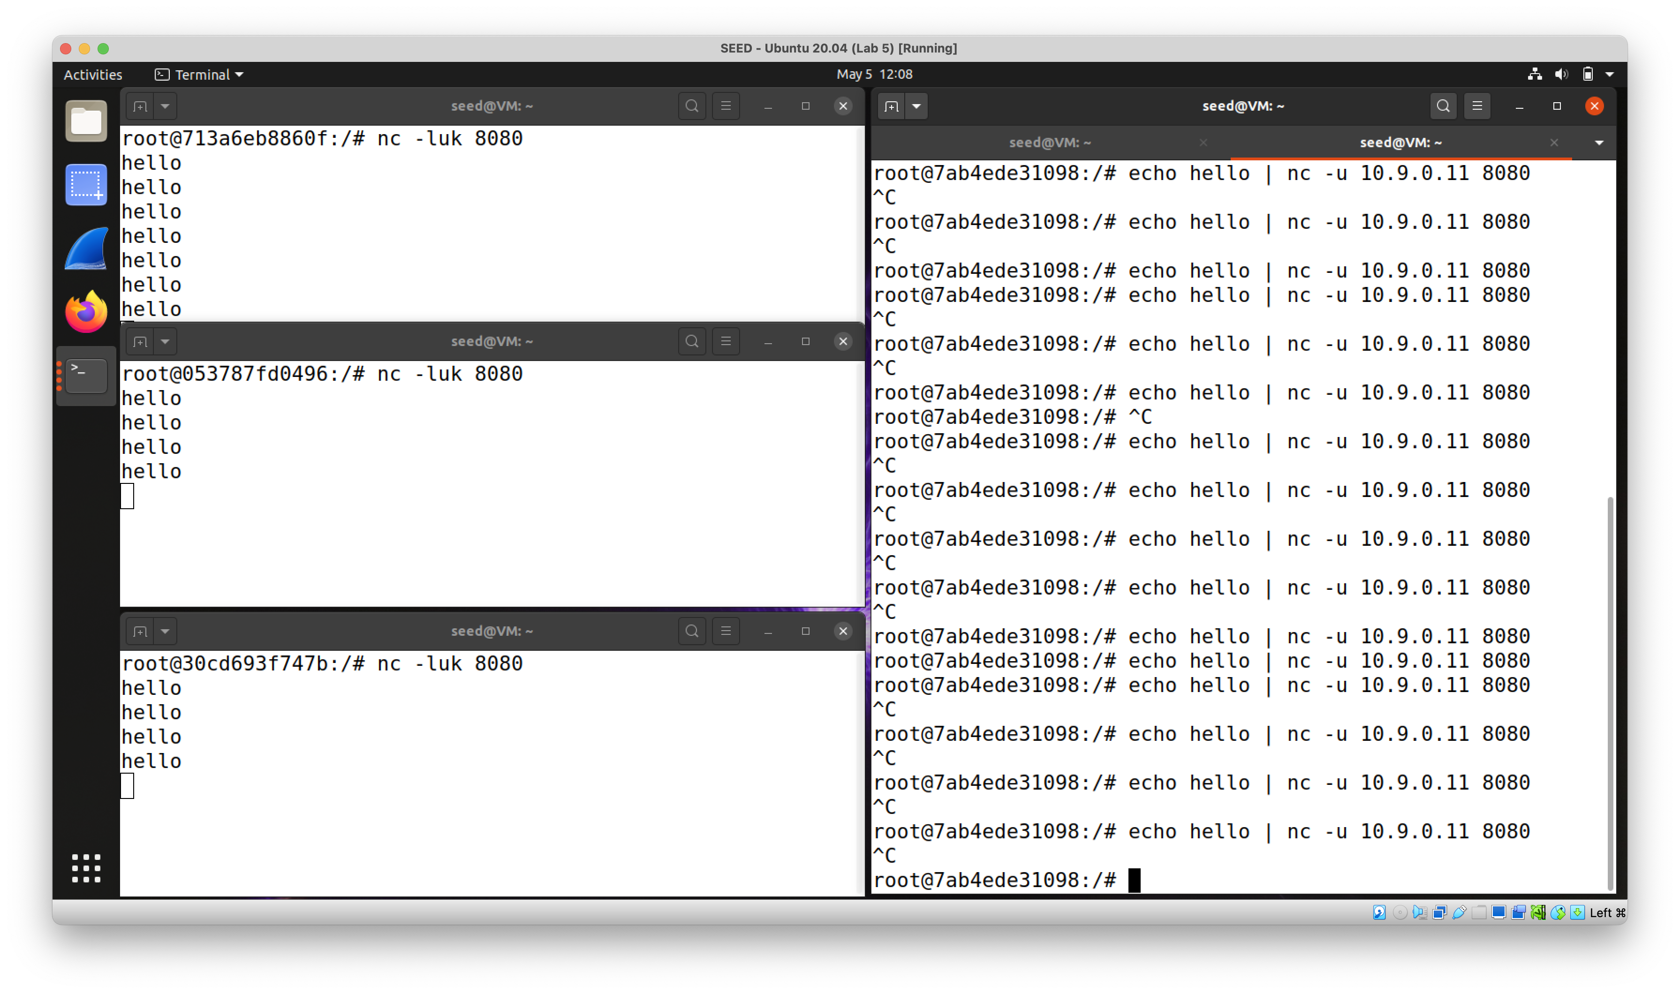

For every 3 UDP packets received by the router on port 8080,

the first one will be sent to 192.168.60.5,

the second one will be sent to 192.168.60.6,

the third one will be sent to 192.168.60.7.

`iptables -t nat -A PREROUTING -p udp --dport 8080 -m statistic --mode random --probability .33 -j DNAT --to-destination 192.168.60.5:8080`

`iptables -t nat -A PREROUTING -p udp --dport 8080 -m statistic --mode random --probability .33 -j DNAT --to-destination 192.168.60.6:8080`

`iptables -t nat -A PREROUTING -p udp --dport 8080 -m statistic --mode random --probability .34 -j DNAT --to-destination 192.168.60.7:8080`

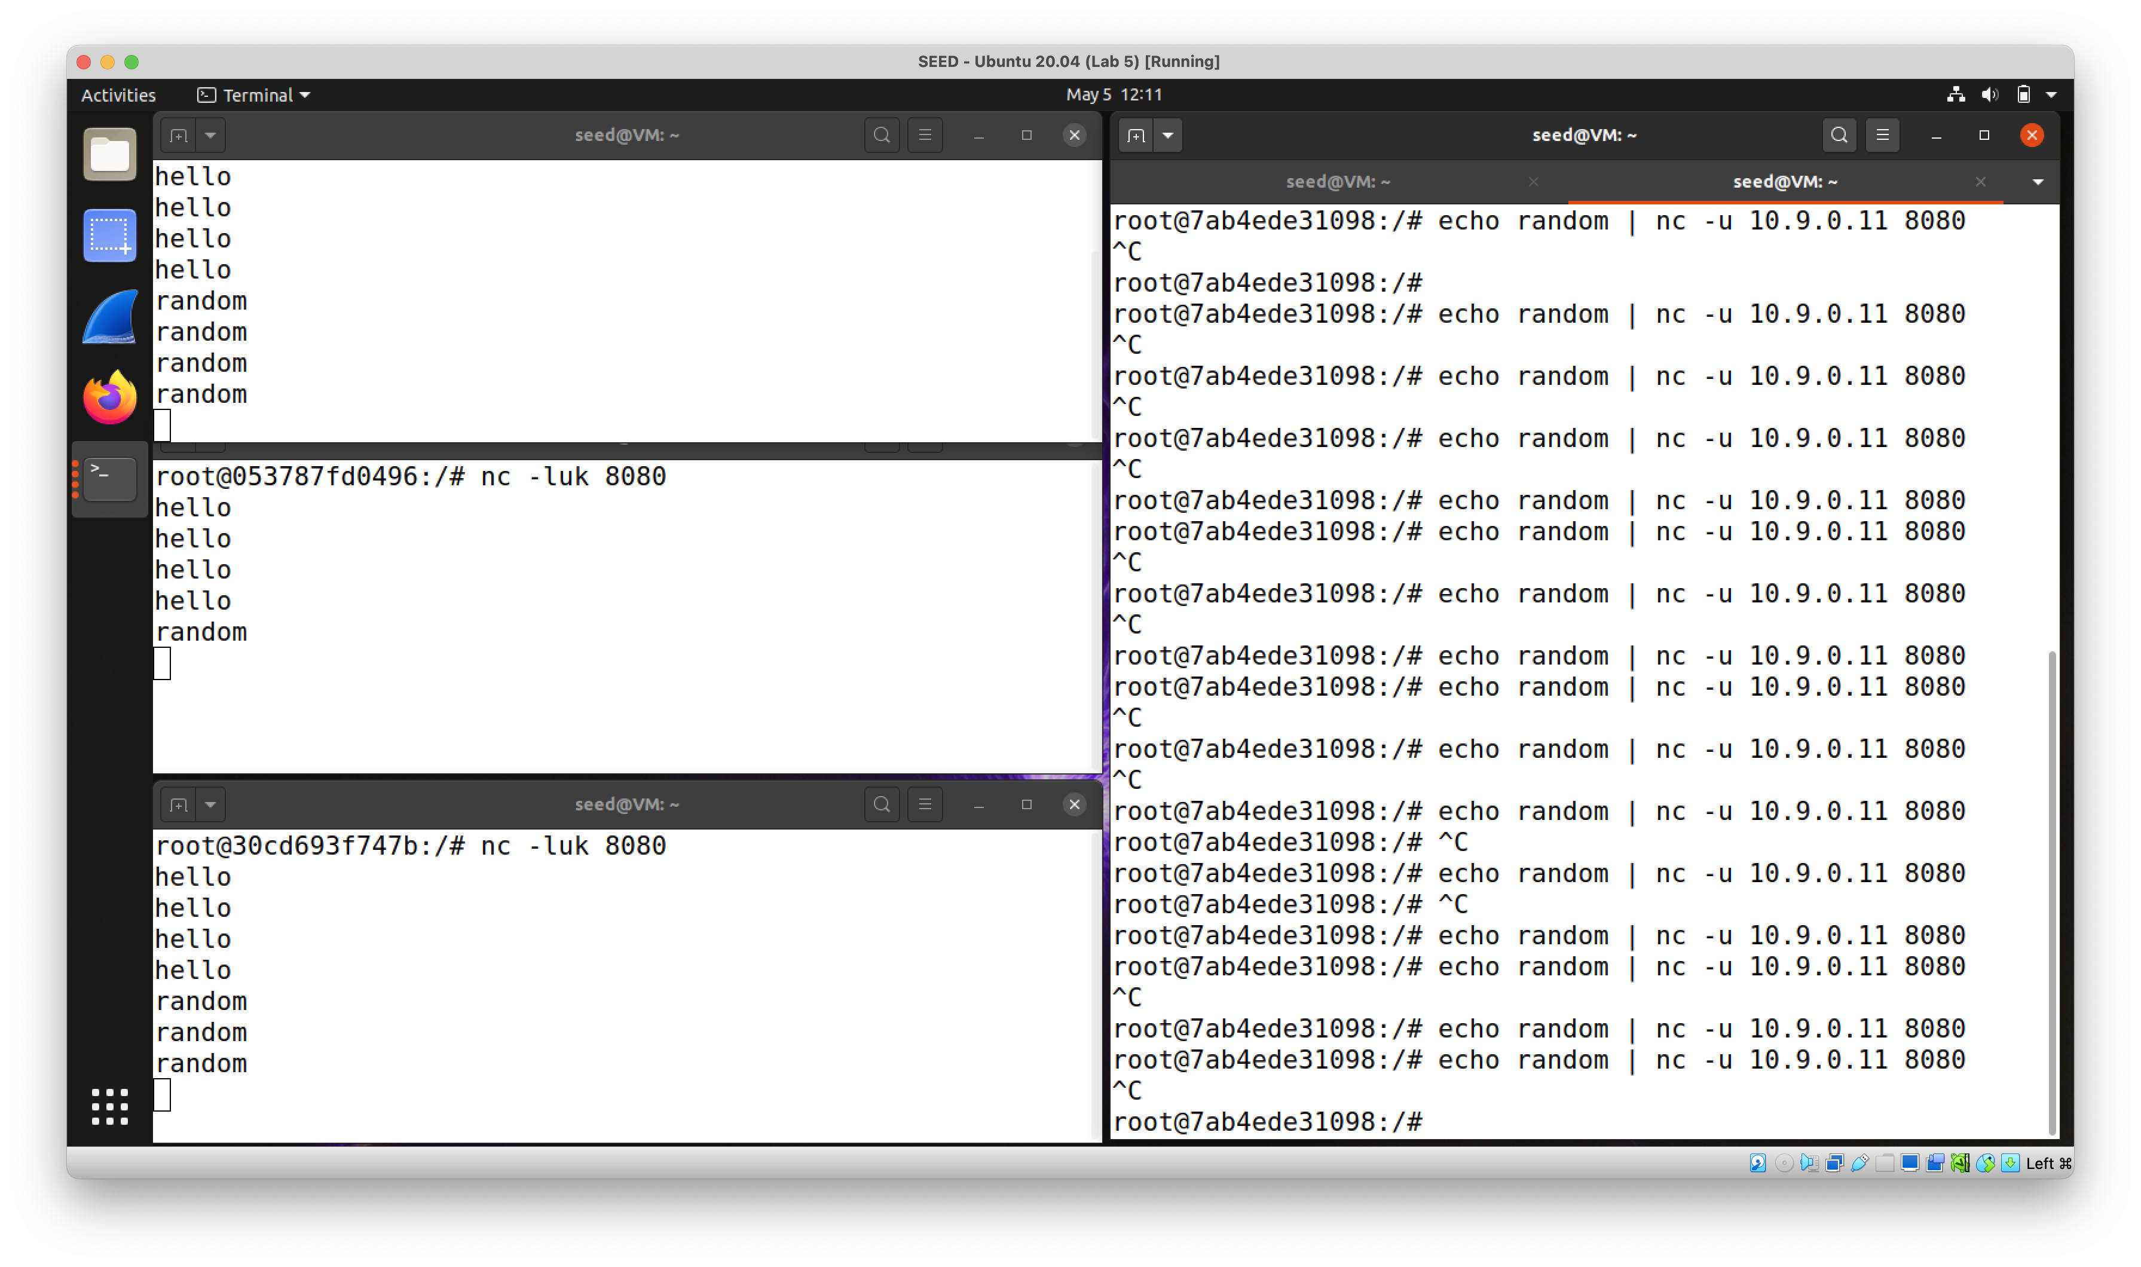

For every UDP packet received by the router on port 8080,

there is 33% chance for it to be sent to 192.168.60.5,

there is 33% chance for it to be sent to 192.168.60.6,

there is 34% chance for it to be sent to 192.168.60.7.

**Writeup**

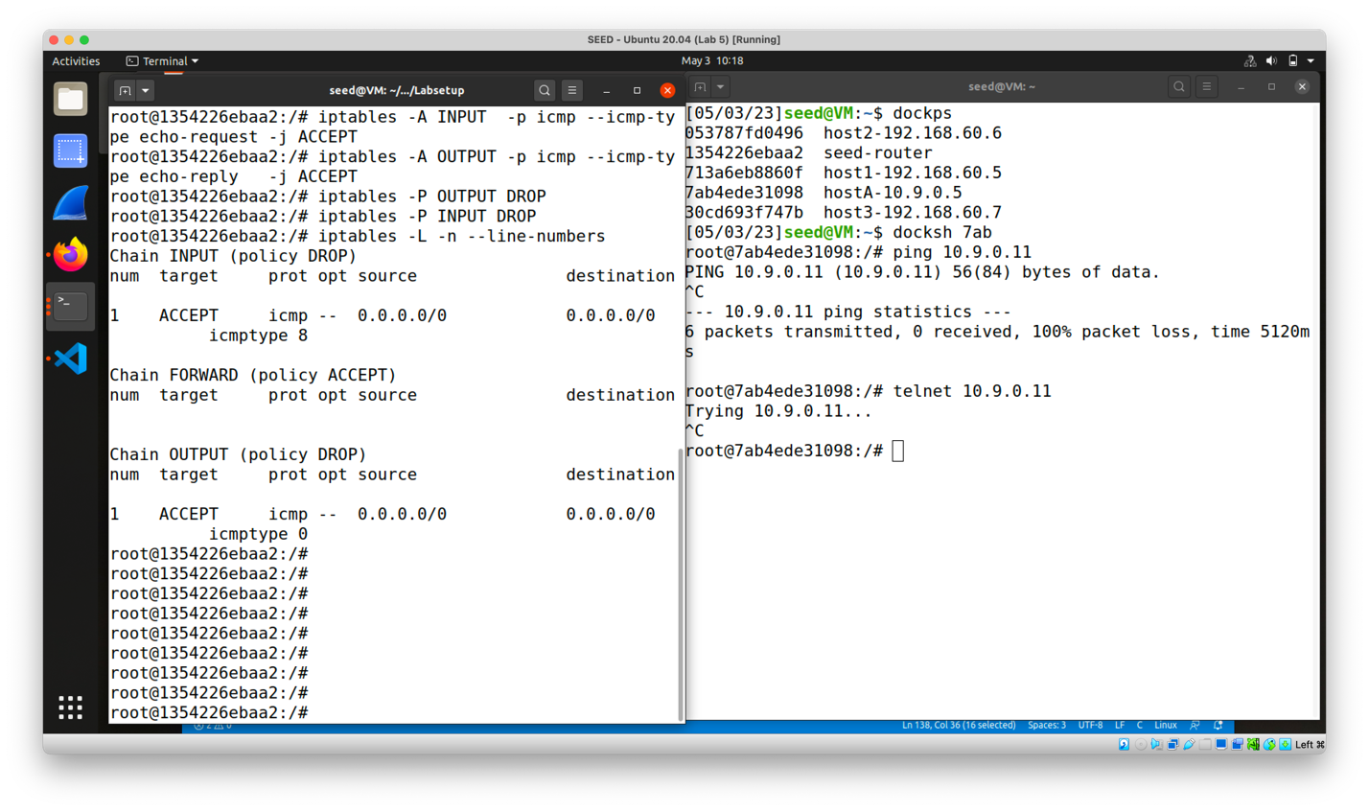

Some problems that I ran into includes forgetting to unload seedFilter from kernel from proceeding to Task 2.A, causing both ping and Telnet not working before any iptables firewall rule is set.

Through the lab I learned some basics about how firewalls are implemented in Linux through kernel module. I also gain more knowledge of the functionality of usage of iptables, a powerful built-in firewall on Linux. Correctly configuring the firewall requires understanding of network traffics to predict their flow and patterns. Edge cases consideration is also crucial in protecting the network. This lab provided me some insights on one of the important tasks of network security engineers.